MR. RAHUL ANIL JICHKAR
Permanent Address
48, Ramna Maroti Road,
Gadge Nagar, Nagpur-09.
E-mail: rjichkar@gmail.com Mobile No: +91- 9960950516.

OBJECTIVE

A challenging career that will enable me to exhibit my professional competency to the zenith and will enable me to expose my talent to the max, to reach the heights of success.

EXPERIENCE SUMMARY

- Have excellent work ability, goal-focused Sr. Consultant offering 8.9 years of experience in software industry.
- Over 6.9 years of experience in developing CRM applications on Salesforce.com.
- Worked closely with Sales and Operations management team and gathered the requirements from business teams at onsite (Los Angeles, U.S) and implemented the system as per their business requirements.
- Designed and implemented successful solutions to meet customer requirements along with building maintainable, scalable applications, ensuring long-term customer success.
- Proficient in building Force.com applications using APEX, VF Pages, Triggers, Lightning Aura Framework, LWC , HTML, Java Script, Web Services.
- Experience in Deployment, Data Migration and Integration with External application.
- Salesforce Application Architect Certified along with other salesforce certifications mentioned in the certification section.
- Working exposure to Agile & Waterfall Methodology.
- Holding valid H1-B Visa till Aug-2021.

PROFESSIONAL SUMMARY

EMPLOYER | ROLE | DESIGNATION | FROM_DATE | TO_DATE | TOTAL YEARS
TEK Systems Global Services | Technical Lead | Technical Lead | Nov-2020 | Currently Working | 2 Month
Deloitte U.S India Pvt. Ltd. | Development  (Salesforce Developer) | Sr. Consultant | Feb-2017 | Nov-2020 | 3.4 years
Deloitte Consulting LLP, Los Angeles, U.S. | Release Manager /Support Lead | Sr. Consultant | May-2019 | March-2020 | 10 months
Persistent  Systems Ltd. | Development &  Support | Senior Software  Engineer | Aug-2014 | Jan-2017 | 2.7 years
Tata Consultancy Services, Pune | Application Development & Maintenance | Assistant Systems Engineer | Dec-2009 | Jan-2012 | 2.1 years

EDUCATION DETAILS

QUALIFICATION | SPECIALIZATION | BOARD/UNIV. | YEAR | MARKS
High School |  | Maharashtra State Board | 2003 | 80.33%
Intermediate | Electronics | Maharashtra State Board | 2005 | 89.33%
B.E | Computer Technology | Nagpur University | 2009 | 73.71%
M. Tech  (GATE Qualified) | Computer Science & Engineering  Specialization: Mobile  Ad-hoc Networks | RCOEM Autonomous Institute | 2014 | CGPA: 9.53

CERTIFICATIONS

- Oracle Certified Java Programmer (OCJP) for Java 6.
- Other SF certifications details given below,
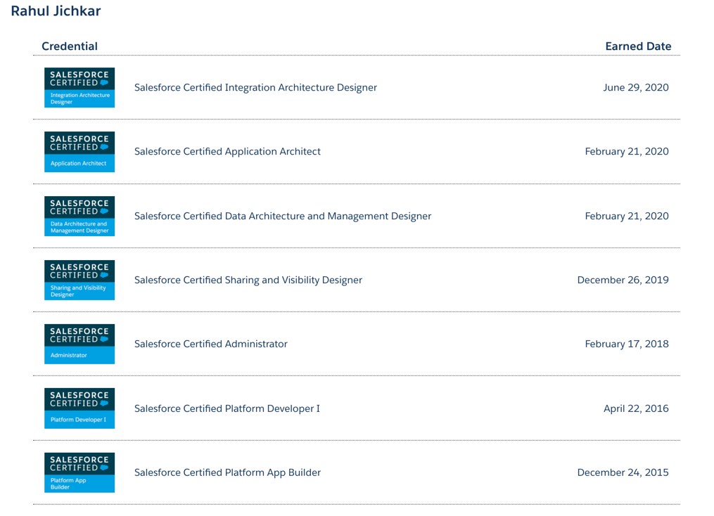

ACHIEVEMENTS

- Developed a utility on Lightning platform to bulk Create/Update the Custom Metadata and it was amongst the Top 3 utilities in “Lightnathon” event conducted by Deloitte SFDC practice.
- Awarded “You Made a Difference” for Excellent Customer Appreciation by Persistent Systems Ltd.
- Awarded “Applause Award” twice for Excellent Performance by Deloitte U.S India Pvt. Ltd.
- Awarded “Gold Medal” for being 1st Topper in M.Tech (CSE) during session 2012-14.
- Published two research papers in International Journal of Computer Science.

SKILL SET

- Cloud Computing | Salesforce.com, Sales Cloud, Community Cloud, Marketing Cloud
- Languages | Java, Apex (Salesforce)
- Scripting Language | JavaScript, JQuery
- SF Dev Tools | Force.com IDE (Eclipse), SFDX, ASIDE, Mavensmate, VS Code
- SF Data Migration Tools | Apex Data Loader, dataloader.io, Workbench
- SF Deployment Tools | Change Sets, ANT Migration Tool, Jenkins Pipeline, Click Deploy
- Operating Systems | Windows, Mac, Linux
- Frontend Technologies | Swing (Java), HTML, PHP, XML, Visualforce, Javascript, AJAX, JQuery
- Serverside Technologies | JSP, Servlets, Apex
- Frameworks | Basics of Spring MVC, Hibernate
- Databases | MySQL, Oracle
- Web Services API | REST API
- Servers Used | Websphere Application Server (WAS) 6.1,  Apache Tomcat , Glassfish Application Server
- Other Tools | Quartz Scheduler, TOAD, MySQL Workbench,  IBM RAD, Eclipse, Netbeans
- Mobile Technologies | Android Basics

PROJECTS

Lightning Experience /Sales Cloud Customization Project

Project #1
Project Title: Underwriting Application for Acquisition Analyst

Customer: Imajn Home / Sparrow Now(Real Estate Firm)

Description:
This application is targeted to the Acquisition Analysts who always strive to find the properties which are meeting the firm criteria and can be possible candidate for either Sales or Renting the property, and the complete process is called as “Underwriting”.
The application gives the analyst the overall view of the property along with the properties which are nearby to the reference property or the property which the user is currently underwriting. The data used in these operations is fetched from the MLS (Multiple Listing Service) using REST callouts.
Team Size: 1 members

Role/Responsibilities:
- As I was the only team member in the team, I managed to handle all the roles like,
Requirement gathering,
  - Design
  - Development
  - Testing
  - Deployment

Platform/ Framework/ Libraries involved: LWC, Aura, VF, Salesforce Lightning Design System, MLS Rest Service, Batch Apex with Iteration, Google Geocoding API.

Lightning Experience /Community Cloud Projects

Project #2
Project Title: Indiana Community Connect (Resource Engine)

Customer: State of Indiana

Description:
This is a community portal where all the citizens of the state can get connected to the nearby support services and resources. This community portal is based on the pre-built asset which was developed for the state of KY. Along with this, it also facilitates the Community Partners to create Referrals for their organization or services and get an holistic view of the overall performance of their resources.

Team Size: 7 members

Role/Responsibilities:
- Code review of the components developed by the team.
- Managing the Team and their tasks
- Sprint Estimation and Team Capacity Planning
- Refining client requirements and deciding the most suitable approach to accomplish the use case
- Worked on DevOps tools (ClickDeploy) for daily deployment and sprint releases
- Worked as a developer for customization using Apex classes, Lightning Components, REST API Integration, Triggers, Workflow rules and validation rules.

Software Tools: Community Cloud, Lightning Community Pages, Lightning Components, Salesforce Lightning Design System, Google Analytics.
Lightning Experience /Sales Cloud

Project #3
Project Title: Marketing 360

Customer: Disney ABC Television Group

Description: The Marketing Ecosystem Program is a multi-year initiative that aims to consolidate the system landscape across ABC, Disney Channels Worldwide, and Freeform in order to streamline and better enable Marketing (Campaign Planning and Management), Financial Management, and Operations Measurement and Tracking activities.
Initial phase of the project was targeted to build Campaign Strategy to define overall marketing strategy, messaging, and brand guidelines and then later build a marketing plan based on campaign strategy. Later phase of the project is targeted for Campaign execution build in previous phase using asset plans, tracks and destination & supported by jobs assignment to different people.

Team Size: 7 members

Role/Responsibilities:
- Did code review for the components developed by the team.
- Worked as a developer to create custom objects, Apex classes, Lightning Components, REST API Integration, Triggers, Workflow rules and validation rules.

Software Tools: Salesforce Cloud Platform (Enterprise Edition), Lightning Components, Salesforce Lightning Design System.

Lightning Experience /Sales Cloud

Project #4
Project Title: Television Distribution (TVD)

Customer: Fox Television Distribution Group

Description: The Fox Television Distribution group is experiencing rapid growth. Moreover, the global sales team is challenged by the fragmented and manual nature of retrieving information in areas such as visibility of customer purchase history, deal pricing and compliance, communication and collaboration, reporting and analysis, as well as forecasting and planning. To better support the organization, Fox has implemented a Salesforce Customer Relationship Management (CRM) solution named as “TVD” aka “KIWI”.

Team Size: 5 members

Role/Responsibilities:
- Did code review for the components developed by the team.
- Worked as a developer to create custom objects, Apex classes, Lightning Components, REST API Integration, Triggers, Workflow rules and validation rules.

Software Tools: Salesforce Cloud Platform (Enterprise Edition), Lightning Components, Salesforce Lightning Design System.

Lightning Experience /Community Cloud

Project #5
Project Title: Aabaco Community (Salesforce Napili Community)

Customer: Aabaco Small Business by Yahoo Inc.

Description: Aabaco Small Business from Yahoo! has been serving small business owners for 18 years. Formerly known as Yahoo! Small Business, the business has recently gone through a rebrand. Aabaco Community is the application mainly developed for small business users to know information about various products and services offered by Aabaco. The community is built on Napili template to provide smooth user experience.

Team Size: 2 members

Role/Responsibilities:
- Requirements gathering directly from client through calls or emails.
- Development of lightning components for Napili pages.
- Configure ‘Live Agent’ for Napili community.

Software Tools: Salesforce Cloud Platform (Enterprise Edition), Lightning Components, Salesforce Lightning Design System.

Lightning Experience /Service Cloud

Project #6
Project Title: Engagement Center (Salesforce Service Cloud)

Customer: Evariant Inc.

Description: Evariant is a healthcare company on a mission to help make the health system work better for everyone. The “Engagement Center” is a healthcare vendor oriented app developed in Salesforce Service cloud to maintain the information about Patients & Doctors in an organized manner. The agents on the vendor side will schedule appointments for patient or suggest appropriate doctor to consult for the stated symptoms by the patient.

Team Size: 5 members

Role/Responsibilities:
- Requirements gathering directly from client through calls or emails.
- Marketing cloud Integration & Configuration.
- Configure email templates and send emails using triggered send feature in the marketing cloud.
- Development of dynamic dashboard using lightning components.
Software Tools: Salesforce Service Cloud (Partner Developer Edition), Marketing Cloud (Exact target), Lightning Component.

Healthcare / CD Tool

Project #7
Project Title: Optum One (Salesforce)

Customer: Optum Inc.

Description: Optum™ is a health services and innovation company on a mission to help make the health system work better for everyone. They combine data and analytics with technology and expertise to power modern health care. In collaboration with their partners, they focus on three key drivers of transformative change: modernizing the health system infrastructure, advancing care and empowering consumers.

Team Size: 4 members

Role/Responsibilities:
• Change set deployment using ANT migration tool.

Software Tools: Salesforce Cloud Platform (Enterprise Edition), ANT migration tool.

Apex/VF Development

Project #8
Project Title: Ben & Jerry Homemade Inc. CRM Application (Salesforce)

Customer: Ben & Jerry Homemade Inc.

Description: Salesforce is an on-demand CRM solution that improves sales attainment, account visibility, and also stores key information in account, contact, and opportunity records:
• Deepens customer relationships
• Facilitates team communication and collaboration
• Streamlines pipeline reporting and forecasting

Team Size: 1 members

Role/Responsibilities:
• Fixing of bugs on priority basis.
• Requirements gathering directly from client through calls or emails.
• Development of new modules.

Software Tools: Salesforce Cloud Platform (Enterprise Edition), Force.com IDE, ASIDE.IO, Data Loader, Conga Composer.

PERSONAL INFORMATION

Name | - Rahul Anil Jichkar
Father’s Name | - Shri.Anil Namdeorao Jichkar
Date of Birth | - 9- June-1987
Alternate Mobile Nos. | - 9970955762, 9503354067
Alternate Email | - rjichkar@yahoo.in
Hobbies | - Reading Tech Articles, Watching Movies,  Travelling, Badminton
Sex | - Male
Marital Status | - Married
Languages Known | - Marathi, Hindi, English
Mother Tongue | - Marathi

I hereby declare that the above written particulars are best of my knowledge and belief.

Place: Nagpur Rahul A Jichkar

