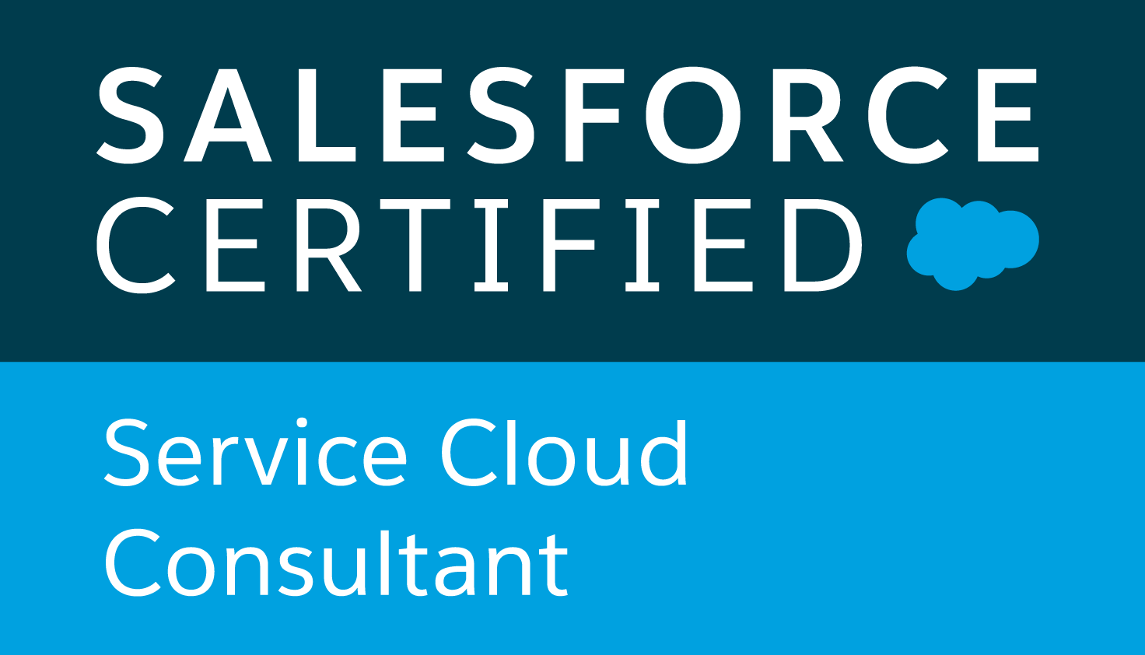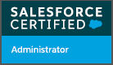

**Sravan Kumar Jagarlamudi**

**(Mobile: +91- 9743106096 / E-Mail:** [**sravan.jagarlamudi@gmail.com**](mailto:sinharishikesh11@gmail.com)

**(Open to relocate)**

* Overall 4.8 years of IT experience and having relevant Salesforce CRM Administrator and Consultant with 4 years of experience with organizational customer service and project management skills. Developing business processes and system solutions for Health Care Industries,Real estate and shipping industry for various projects from conceptualization to implementation.
* Experienced in **Digital Marketing ( SEO, Google Ad words )**
* Quality years of experience with Sales force **Configuration, Security, Change Management, Risk Management, Deployment, Sandbox implementation and monitoring**.
* Strong Knowledge on **SFDC standard Data structures** and familiarity with designing Custom Objects on Force.com platform and Force.com Sites.
* Design Functional Requirement and Technical Specification Documents.
* Extensive experience using Salesforce Administration (SFA), **Profiles, Roles, Page Layouts, OWD, Sharing rules, Permission Set, Record Types, Work flow rules, Approval process, Assignment Rules, Validations, Reports and Dashboards.**
* Extensive experience using **Data Management and Migration tools like Apex Data Loader and Workbench.**
* Assess the impacts on technical design and users because of the changes in functional requirements.
* Working on all module of **sales cloud and Service Cloud**

**PROFILE SUMMARY**

* Currently working in **Solverminds Solution Pvt. Ltd.** .
* Endowed with a passion for winning as apparent through demonstrated excellence in academic & extracurricular areas
* Strong knowledge in **Salesforce** Administration and customization & configuration.
* Gathering business requirements and managing business process automations like Marketo,B+S suiter Cisco, Etc..
* Managing **4700+ End users day to day Salesforce Admin and enhancing applications support**.
* Ability to work in a dynamic environment & under pressure situations.

|  |
| --- |
| **Work Experience** |

##### Experience:

* **Solver Minds Solutions & Technologies Pvt. LTD.** As **Sales force Administrator ( May** 2019 to till Date)
* **Amtex Info Solutions Pvt.Ltd**.As **Software Engineer.**

**Projects:**

**Solver Minds Solutions & Technologies Pvt. LTD. , Chennai India.**

**Project: Haag-Lloyd ( HLAG, IT Service Center ) May** *2019 to Till date*

***ITSC\\ Sales-force*** *support & enhancement team.*

**Client  *: Haag-Lloyd* AG**is a German international shipping and container transportation company. It is currently the world's fifth largest container carrier in terms of vessel capacity***.***

**Roles & Responsibilities:**

* Provide support over 4700 user worldwide and responsible as **POC** .
* Deploying the changes and configurations by using The **Change set & ANT force.com Migration tool.**
* **Conduct training programmers for new users before releasing their license and updates for others on new releases/capabilities before going live.**
* Maintain and customize Salesforce.com scopes for standard **objects like accounts, contacts, opportunity, Products and custom objects, object relationships etc., to support vital business functions.**
* Work with business super users to configure and manage complex user accessibility settings using T**erritories, Permission sets, Sharing Rule, Queue, Groups, FLS etc. to ensure system security.**
* Decides and defines the **Roles and Profiles in CRM for each new user depending on their Business role in the organization**.
* Overall fully optimize work flow and increase both comprehensibility and potential of clients to utilize Sales Force .
* Track and perform daily routine necessary activities such as **merging duplicates, task assignments, maintaining and upgrading security permissions, & more**.
* Ensure data integrity through the appropriate use of De-duplicating, loading and exporting tools, for bulk of data using **Import Wizard**,**Data Loader and Workbench**.
* Successfully implemented Automated processes by using **Process Builder and Work flow rules.**
* Proposed and implemented successfully **Email 2 Case** functionality for the support teams.
* **Outlook Configuration, SSO settings in HLAG**.

**Projects:**

**Amtex Info Solutions Pvt.Ltd as Software Engineer.**

**Project:** **British Co. Group of Realtors.**

*Product Support Specialist | Salesforce Jan 2016 to April 2019*

**Client**: **British Co. Group of Realtors.** - is a Fortune 500 company and the world’s largest provider of Real state development. Focused primarily on construction and Analytical services.

Unlimited edition with 8500+ Standard licenses, Salesforce here is being Implemented as a Mother system to 10 other applications where the downstream runs. Applications like **Box, Orgchart**, etc. makes the system more efficient to run the business and fulfilling the client’s requirement. Salesforce here mainly focuses on **Client’s Accounts their related Opportunities and ending with Contract generation**.

Responsibilities-

* Manage ongoing support request and administrative needs of users.
* Provide support to over 8500 standard Salesforce users worldwide and act as a lead to the primary contact team for end-user support.
* Conduct training programmers for new users before releasing their license and updates for others on new releases/capabilities before going live.
* Maintain and customize Salesforce.com scopes for standard objects like accounts, contacts, opportunity, Products and custom objects, object relationships etc., to support vital business functions.
* Work with business super users to configure and manage complex user accessibility settings using Territories, Permission sets, Sharing Rule, Queue, Groups, FLS etc. to ensure system security.
* Decides and defines the Roles and Profiles in CRM for each new user depending on their Business role in the organization.
* Track and perform daily routine necessary activities such as merging duplicates, task assignments, maintaining and upgrading security permissions, & more.
* Ensure data integrity through the appropriate use of de-duplcating, loading and exporting tools, for bulk of data using Data Loader and Workbench.
* **Configure Fields, pick lists, record types, page layouts, work flows, approval processes, validation rules, Salesforce for Outlook, Document templates etc.**
* Creates **Work flow, Triggers and also use Process Builder and Flows to atomize and meet business needs.**
* Assist users with **reports and dashboards design to track pipeline/stages** for management visibility and individual level.
* Manage multiple **sandbox environments and schedule and monitor the sandbox refresh**.
* Monitor team’s adoption rates and respond as needed providing them with training sessions, communication and documentation as needed.
* Analyze current processes and make recommendations for enhancements as an initiative to continual improvement.
* Keep up-to-date on technology trends, developments & best practices to meet constantly ever changing environment in which clients demand could change anytime.
* Implemented and maintain several **SFDC packages to meet the business needs**.

**EDUCATION**

1. Bachelor of Computer Application : 2012- 15

**IT SKILLS**

* CRM : Salesforce
* Salesforce Technology:A**pex Classes, Apex Triggers, SOQL, SOSL, Visual Force Pages & Controllers, Work flow & Approvals, Dashboards, Reports, Analytic Snapshots, Custom Objects, Force.com Eclipse IDE Plug-in.**
* Languages : SQL, Apex
* Data Base : MS-Access 2000/2007

**CERTIFICATION**

* **Salesforce Certified Administrator (No expiry)**
* **Salesforce Certified Service Cloud Consultant (No expiry)**

|  |
| --- |
| **Achievement** |

**Received ‘Best solution provider to User for the Quarter 3rd 2018 in Amtex.**

**PERSONAL DETAILS**

Address: H.no.1C, Ponniyamman temple cross street, Sholiganallur, Chennai,600119..

Languages Known: English and Telugu,Tamil,Kannada,Hindi.