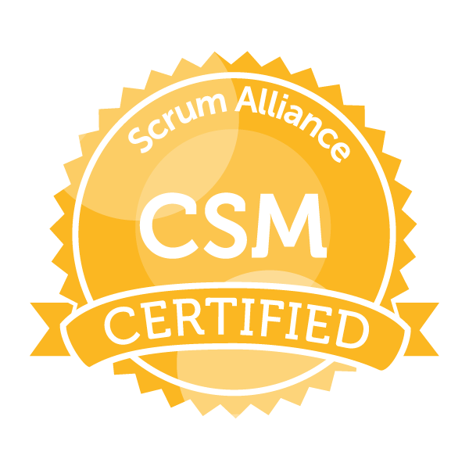
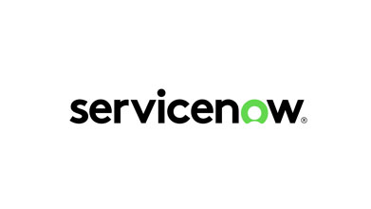
PARIS KAPOOR

Mobile: +91 9840416267
apk2001@gmail.com

PROFILE SUMMARY

A technically competent IT professional with an experience in ServiceNow development, integration, implement complex workflows and customize within the SNOW platform.

- Experienced in ITSM, CSM, GRC, SecOps, Service Portal, Agent Workspace, Custom Applications and Integrations.
- Creating and managing products in all aspects of the Agile (SCRUM)Software lifecycle towards the Quality delivery.
- Involved in all phases of the SDLC including proposals, requirement gathering, planning, estimation, scheduling, POC’s, defect tracking and reporting.
- End to end delivery experience starting from initiation through to final delivery.
- Encourage the team to adopt agile working methods by providing training and mentoring.
- Work with developers, SMEs, and Compliance teams to obtain a well-rounded understanding of what is being asked for and our ability to deliver it.
- Exposure in development and maintenance of JAVA / J2EE enterprise applications.
- Excellent knowledge of BSS and OSS, as well as PSTN, Broadband, TV, and MVNO.
- Domain expertise in Telecom, BFSI, Ecommerce, Retail and Finance Reporting.
- Proven Test-Driven Development.
- Proven continuous improvement and customer negotiation skills.
- Manage and schedule module releases, monitor, track progress and ensure required reporting.

TECHNICAL SKILLS

- ServiceNow ITSM, CSM, ITOM, GRC, SecOps, Service Portal, CMDB, UI Builder, Agent Workspace.
- ServiceNow Scripting: HTML, CSS, JavaScript, jQuery, Bootstrap, AngularJS, Glide Script
- ServiceNow Integration: eBonding JSON, XML, REST API, SOAP
- Application Servers: IBM Web Sphere, BEA Web Logic, JBoss, Apache Tomcat
- Database: Oracle, SQL
- Version Control: CVS, PVCS, SVN, Git, GitHub
- Build Tools and Platforms: Ant and Maven, CI/CD, Jenkins, Docker, Windows, UNIX, LINUX, AWS
- Tools: PuTTY, Git, GitHub, uDeploy, Teamcity, VSS, JIRA, Confluence, Serena Tracker, HP SaaS QC, SharePoint.

CERTIFICATE & RECOGNITION

- ServiceNow Certified Application Developer (CAD).
- ServiceNow Certified System Administrator (CSA).
- Scrum Alliance Certified Scrum Master (CSM).
- Completed the course in ServiceNow Certified Implementation Specialist-Customer Service Management.
- Completed the course in ServiceNow Certified Implementation Specialist-IT Service Management.
- Completed the course in ServiceNow Security Operation (SecOps).
- Completed the course in Atlassian Agile with Atlassian JIRA.
- Completed the course in AWS Associate Solution Architect.
- Outstanding delivery performance as measured by the PRISM certificate.
EDUCATIONAL QUALIFICATION

- Master of Computer Application - Madurai Kamaraj University, Tamil Nadu, India.

PROFESSIONAL EXPERIENCE

Virtusa Consulting Services, Chennai, from 2017 to till date.

Project: Citi Connect EMEA – Citi Bank.
Role: Senior Developer (ServiceNow)

Responsibilities:
- Working on 2 different ServiceNow projects and Lead 1 Scrum Quad consisting of 7 members to streamline.
- Ability to create business rules, email templates and Custom email notification as per customer requirement.
- Experience in create, customize and troubleshoot workflows and service catalogs.
- Create users, groups, roles and assign appropriately.
- Create Transform map to import data.
- Developed, tested and deploy custom applications, workflows and integrations using ServiceNow’s ITSM, CSM and Service Portal.
- Developed and implemented GRC and SecOps module Policy compliance, Policy management, Security Incident Response (SIR), Vulnerability Response (VR), Predictive Analysis, Dashboard and reports.
- Exposure to Risk controls, Risk Management, Vendor Management and Audit process.
- Implemented complex business logic and automation using JavaScript and Glide Script.
- Created and maintained ServiceNow data integrations with third-party system using REST API, SOAP, JSON and XML.
- Conducted training sessions to end-user and provided technical support to ServiceNow application.
- Worked with Product Owners, Users, stakeholders to analyze and validate requirements.
- Managing and tracking projects and stories on JIRA.

Prodapt Solution, Chennai, from 2016 to 2017.

Project: Customer Change Repository – LG Global.
Role: Senior Technical Lead

Responsibilities:
- Hands-on experience beyond ITSM.
- Develop and design application modules, workflows, and Catalog request for our client.
- Develop and execute comprehensive test plans, test cases, and test scripts for ServiceNow applications and integrations.
- Perform unit testing and provide resolution and support changes to production.
- Participating in the configuration of new applications or suites during planning, development, and rollout phases.
- Experience across Waterfall and Agile project methodologies

Tech Mahindra Limited, worked as a Tech Lead, from 2015 to 2016.
Project: BT-Ecommerce (Agent) - British Telecom.
Responsibilities:
- Interact with stake holder/user to understand the business requirements.
- Involved in component design and delivery.
- Used wireframe to create a prototype model.

Mastek Limited, worked as a Project Lead from 2010 to 2015.
Project: BT-Ecommerce (Agent) - British Telecom
Responsibilities:
- Preparing Estimation, Project planning and Delivery.
- Experience in Catalog and Category Management modules.
- Provide technical assistance to team members.

Mphasis Limited, Worked as a Senior Software Engineer from 2006 to 2010.
Project: Navisys – New Product (AIG Sun America)
Responsibilities:
- Involved in coding.
- Prepare Unit test case and test results.
- Handled production support activities.

PERSONAL DETAILS

Passport Number : G7794705
Marital Status : Married
Address for Communication : #5, F1A, 1st Floor, Zam Zam Flats
Subramanian Street
Keelkattalai, Chennai -600 117.

