Chinta Balaji
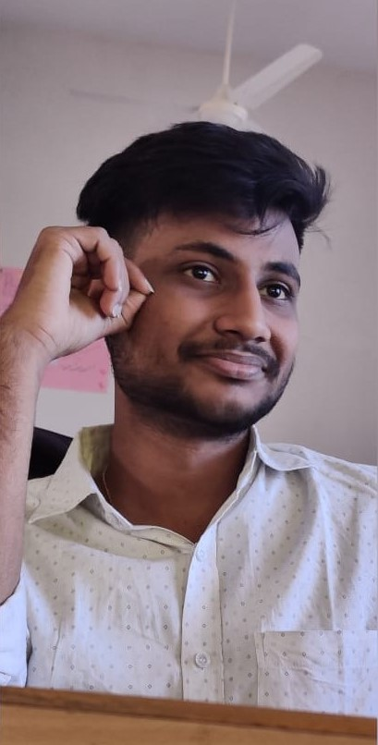
Mail Id: ChintaBalaji.27@vjim.edu.in
Contact No: 8309800328

Career Statement: Seeking an opportunity to get exposure in Finance sector; To polish my skills and to reach organizational targets.

Summary of the skills:
- Hardworking
- Leadership skills
- Good Time management and Ability to prioritize things
- EXCEL, Word, PowerPoint, and Basics of Tableau skills

Course | Institution | Year of passing
PGDM | Vignana Jyothi Institute of Management, Hyderabad | (Pursuing)
B.Com. (Taxation) | Nalanda Degree College, Vijayawada | 2019
Intermediate | Sri Medha V, Vijayawada | 2016
10th | Ravindra Bharathi Public School, Vijayawada | 2013
Educational Qualification:

Internship:-
- Aditya Birla finance limited. – 3 months (Stock markets)

Projects:
- I have completed a project on Fundamental analysis using DCF and Comparables for the company Jubilant Food works.
- Live project in Analyzing & research for Mergers & Acquisition from Mentor minds.
- Live Project in Analyzing the trends in Revenue from Mentor minds.
- Live project in Analyzing the FMCG company from Mentor minds.
- A survey on effectiveness of internet advertisement on consumer behavior.

Certifications:
- Certified in “CPFMSO” course in “BOMBAY STOCK EXCHANGE" regarding Financial Markets and sales.
- I have obtained “STEP” certification facilitated by “THE HINDU” group.
- Certified as Specialist in Microsoft excel by Microsoft.
- I have obtained a certification in Business Simulation (Virtual business game)
- Certificate for completing three live projects from Mentor minds.
- Certificate from "Trak invest" for showing positive returns for 4 weeks.
- Certificate from “Trak invest” for completion the Personal Banking and Finance course
- Certificate from Corporate Finance Institute for completion of Excel crash course.
- Certificate from Corporate Finance Institute for completion of Fundamentals of Credit course.
- Cleared Vocational exam by State government regarding Tally and received Certificate.

Co-Curricular Activities:
- Organized Cultural Events in Chrysalis VJIM.
- Organized Badminton Event in Kritansh VJIM
- Organized “Conquest” (Commerce) Fest in Nalanda Degree College.

Personal Details:
Date of Birth: | 4th April, 1998
Gender: | Male
Father name: | Ch. Venkata Ramaiah
Mother name: | Ch. Parvathi
Languages Known: | Telugu, English, Hindi
Hobbies and Interest: | Playing Cricket & Football, Listening to Music.

Declaration:
I hereby declare that the information furnished above is true and complete to the best of my knowledge.

Ch. Balaji

