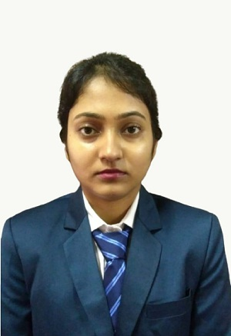

RUPSA DEB
House No.-3, Kalimohan Road, Tarapur,Silchar - 788003
Mobile – 7044204828 II Email ID – rupsadeb1996@gmail.com
LinkedIn URL: https://www.linkedin.com/in/rupsa-deb

Academics:
Name of the Examination | Board / University | Year of Passing | Division / Class / Percentage
MBA (Finance) | St. Xavier’s University | 2021 | 7.73 cgpa
B.Tech. (Civil Engineering) | Heritage Institute of Technoogy | 2018 | 61.1%
XII | Central Board of Secondary Education | 2014 | 70.8%
X | Central Board of Secondary Education | 2012 | 72.2%

Achievements:
- Microsoft Office Excel Specialist certified under Microsoft Inc.
- Data visualization with business intelligence tools.
Extra-Curricular Activities:
Name of the Activity | Year | Division
Drawing | 2006-2010 | First Class

Summer Internship:
Name of the Organization – CFO Bridge Services Private Limited, Mumbai
Project Title – Income tax computation and planning with respect to individual
assessees.

Hobbies and Interests: Travelling, Listening to music

Strengths: Flexibility, Focused

