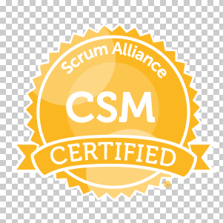 VINOD .Y 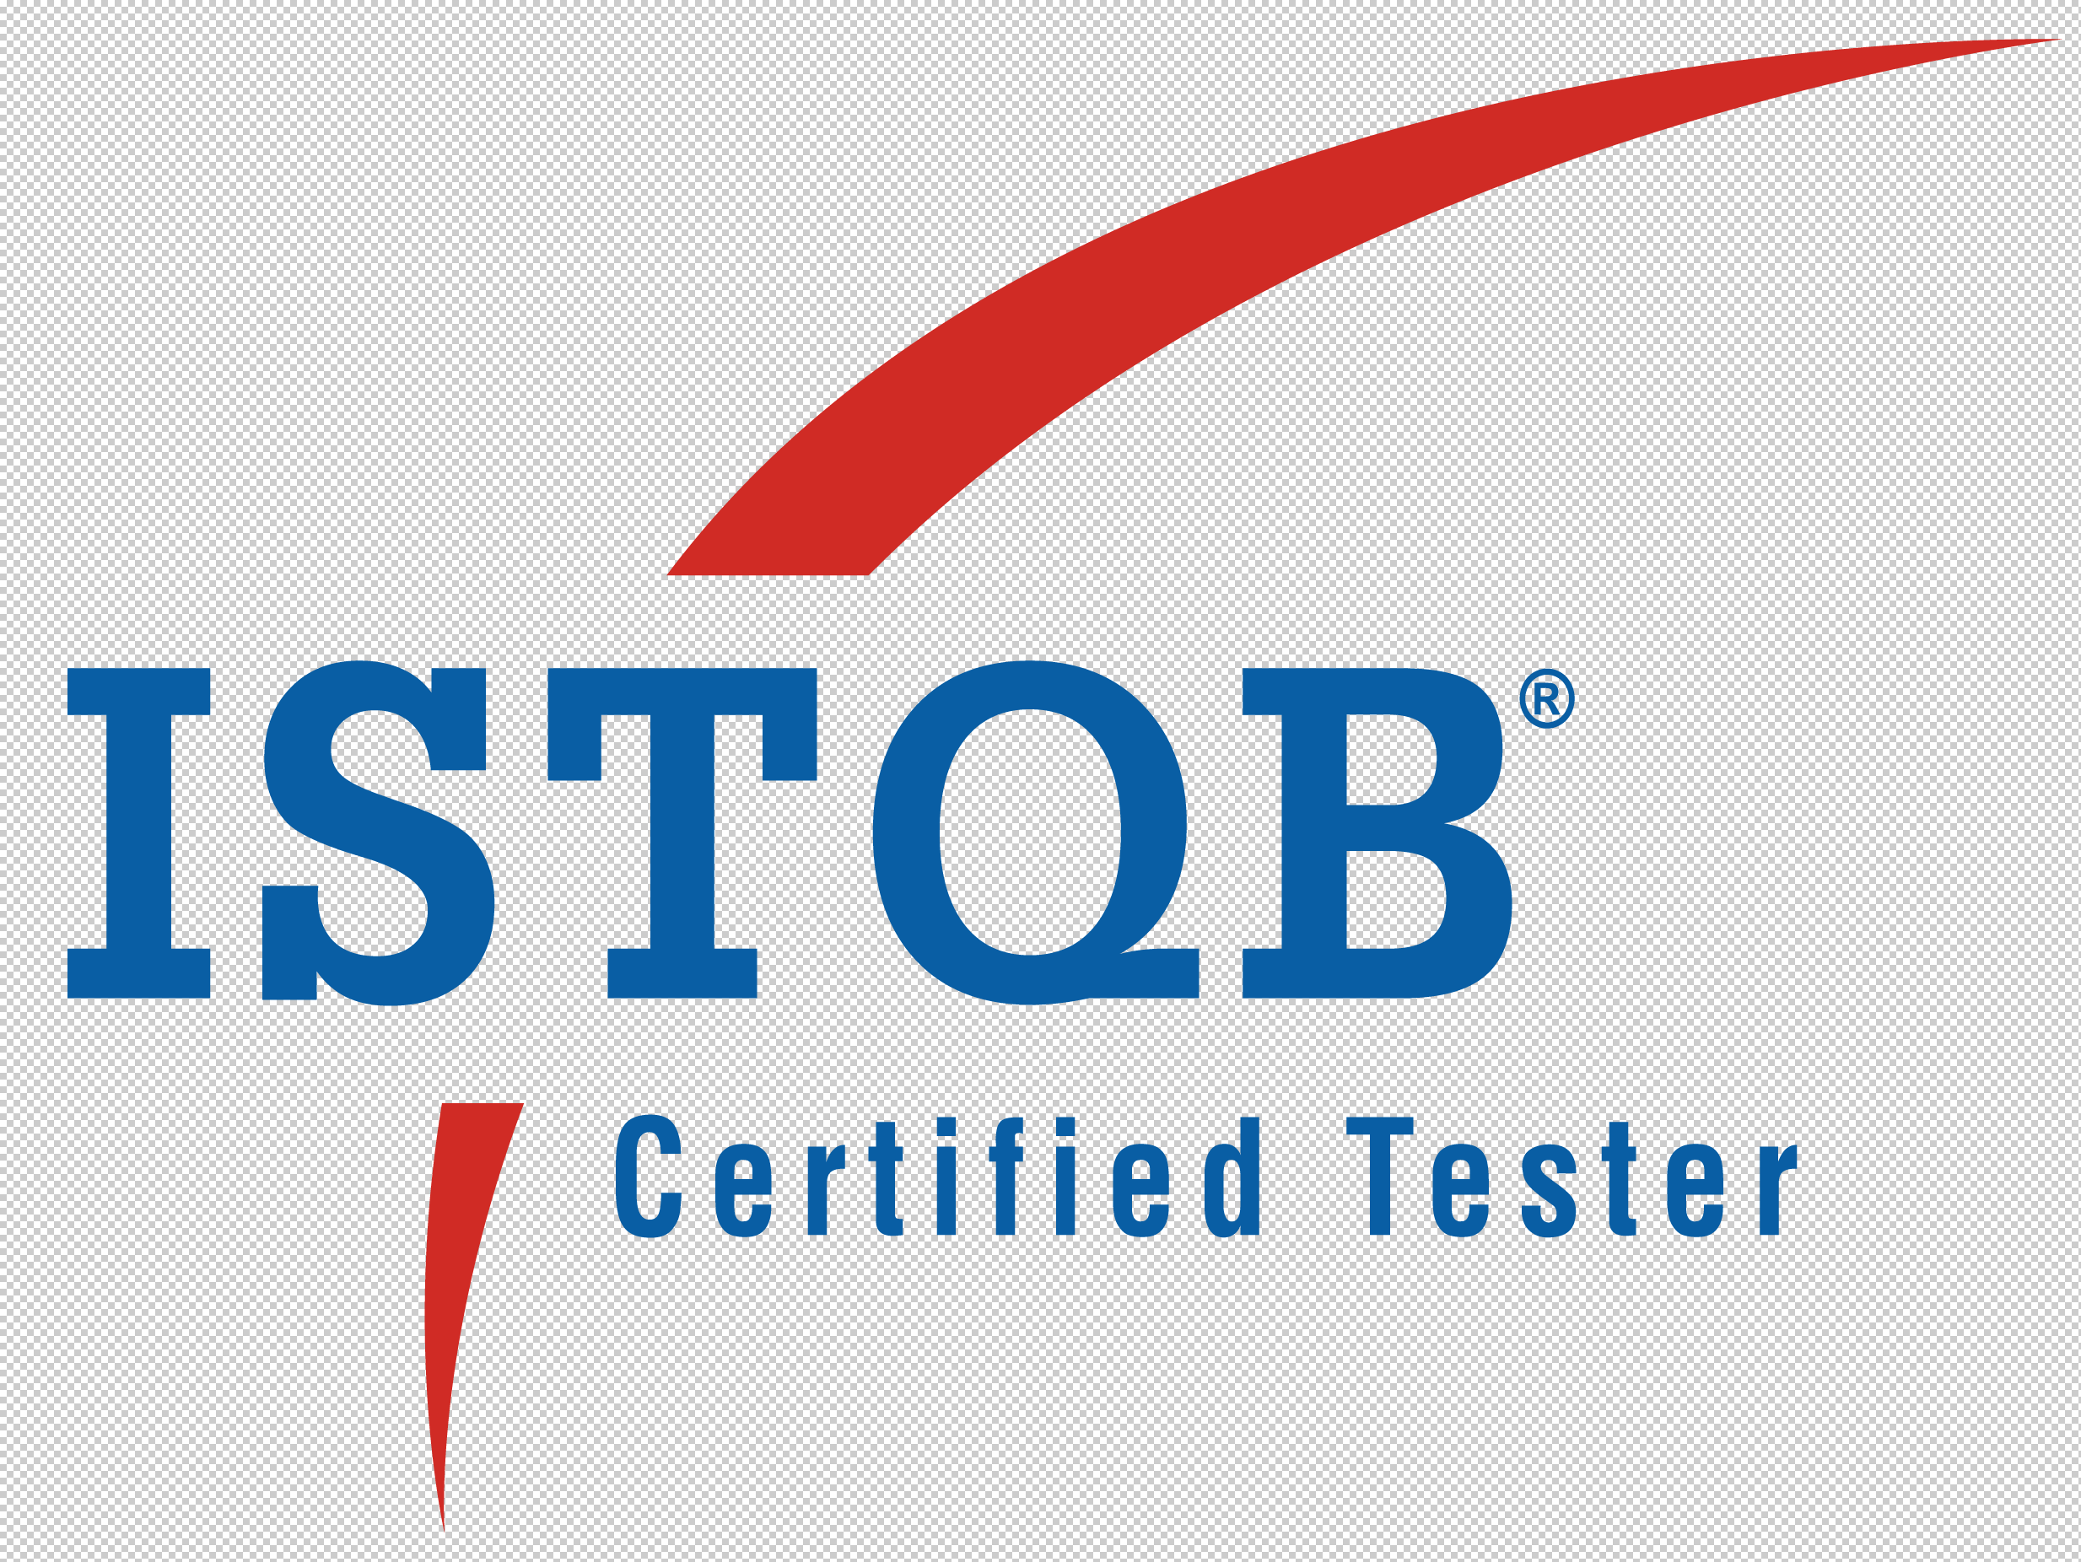
Mobile; 9440805871 E-Mail: yvinod19@gmail.com
PROFILE SUMMARY
- A competent professional with experience in:
Scrum Master, Delivery and Team Management, Quality Assurance & Control
- Associated with Kofax India Pvt. Ltd., Hyderabad, since 12.6 years as Senior QA Engineer/Scrum master leading a team size of 8 members.
- Having 2 years of experience as Scrum master, facilitate daily scrum, sprint planning, Sprint review and retrospective meetings with Team Members.
- Track and remove impediments for the scrum team.
- Follows up on blockers and action items to keep the Scrum Team running.
- Accountable for delivering Service Packs and Hot Fix Deliveries of the product on schedules.
- Successfully executed projects to agreed schedule, budget and scope using agile methodology.
- Communicate with the product owners to understand the requirements of the user stories.
- Liaising with various cross-functional teams like Functional & Technology ensuring proper quality and timely delivery.
- Resources planning and management.
- Identifying & reporting faults through Defect Tracking Tool for centralized information.
- Strong teamwork skills and the ability to communicate with all management levels.
- Hands-on experience in testing web-based applications.
- Knowledge on Robotic Process Automation UiPath tool.
- Adapt in analysing the user requirements and developing test procedures and test cases.
- Sound knowledge of the concepts of STLC and role of QA in testing in Waterfall and Agile methodologies.
- An effective communicator with honed interpersonal, analytical, problem solving and motivational skills.
- Ability to produce bug reports to determine quality levels within a project to senior stakeholders

ORGANIZATIONAL EXPERIENCE

Kofax India Pvt. Ltd., Hyderabad as Senior QA Engineer
Key Result Areas:
- Facilitating daily scrum meetings, sprint planning, review and sprint retrospective with Team Members and Senior Management for the work done.
- Co-ordinating with developers, discussing technical problems, reporting bugs and supporting team in rectifying issues and delivering the product service packs and hot fixes.
- Responsible for creating tenants and users on Azure environment and providing the access to the product for team members.
- Liaising with various cross-functional teams like Functional & Technology ensuring proper quality and timely delivery
- Identifying & reporting faults through Defect Tracking Tool for centralized information.
- Published estimates required for the user stories related to testing of the product
- Delivering and implementing the user stories as per scheduled deadlines
- Conducting retrospective meetings with the team members
- Ensuring that the product deliverables are met as per the SDLC of the product.
- Discussing preliminary stages of the user stories with the core team, project managers and Business analyst.
- Creating and Verifying the Licenses of the product versions as per the requirements on the entire product environment’s.
- Expertise in carrying out System Testing, Web Testing, Functionality Testing, Regression Testing, Sanity Testing and User Acceptance Testing ensuring to meet design specifications, company standards and end user product requirement.
- Preparing test cases and procedures for carrying out Unit, Integration, Validation and Regression Tests at various stages in the SDLC
- Performing various phases of software testing; handling test cases design / strategies / execution / reporting
- Conducting functional tests and analysis of reported defects and assuring that product is defect free with technical specifications.
- Verifying the same functional tests on mobile devices assuring the product is defect free.

ACADEMIC DETAILS
- MCA from DLR College, Kakinada, Andhra University, AP
- B.Sc. from Ideal College, Kakinada, Andhra University, AP

CERTIFICATION
- CSM certification from Scrum alliance in March 2021.
- ISTQB Certification from British Computer Society in 2010.
- Diploma of Completion of RPA testing from Ui Path academy.

IT SKILLS
Operating Systems : Windows 10/ 2K3 / W2k8 / 7
Database : SQL Server2017
Microsoft Tools known : MS Dynamics CRM and Share point
Bug Tracking Tools : Bugzilla, Jira, IBM-Clear Quest and TFS
Performance Testing Tools : JMeter
Robotic Process Automation Tools : Kapow, UiPath
Methodologies : Water Fall & Agile Scrum methodologies.

PRODUCT UNDERTAKEN
Title: Kofax Total Agility (KTA)
Duration: 2007-till date
Team Size: 45
Product Versions: Singularity BPM ver3.7 -- Kofax KTA ver7.8
Database: SQL Server
Operating System: Windows 10
Role: Senior QA Engineer/ Scrum Master
Description: Kofax Total Agility was a BPM suite delivering process design, execution, monitoring & optimization power through 2 user interfaces i.e. Total Agility Designer and Workspace. All functionality was accessible across 2 environments providing one coherent tool for managing complete business process solution. KTA could be deployed on premise and in the cloud via MS Windows Azure. The software supports integration with MS Dynamics CRM, SharePoint and non – MS products such as Content Manager 9.3, etc, Integration with on & off premise data repositories allow organizations to easily extract business data and applied the same to their business processes.
Role:
- Scrum master role facilitating and leading a team size of 8 members.
- Facilitating daily scrum meetings, sprint planning, review and sprint retrospective with Team Members and Senior Management for the work done.
- Follows up on blockers and action items to keep the Scrum Team running.
- Designed, updated & executed test cases to test functionality, after exhaustive discussions with Core Engineering Team on user Stories
- Published estimates required for the user stories in the sprint.
- Prepared complex test scenarios and test data to identify high priority issues within the product.
- Accountable for Service Packs and Hot Fix Deliveries of the product on schedules.
- Two years of experience on Kofax-Kapow RPA tool involved in verifying and executing the test cases of Kapow tool.
- Carried out the testing of product on Client-Server and Micro soft Azure cloud environment.
- Handled the activities related to sign off the user stories of the KTA product.
- Responsible to verify the product connecting to third party tools as Content Manager and CRM.
- Created Unit & Functional Test Cases based on Functional requirements & specifications of the product.
- Executed SQL queries on SQL tables in order to view successful transactions of data and evaluated data
- Tracked & maintained product defects using TFS.

---------x-------x---------

