HARIOM UPADHYAY

B Naryanapura,Bangalore, Karnataka

**Mobile:** +919910269991

Email**:** hariomacet@gmail.com

Skype ID: hariom.upadhyay4

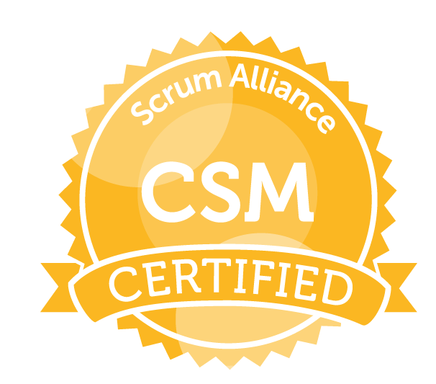

**Career Objective**

To emerge as a key player in a corporate environment where I can quench my thirst for knowledge in the domain of IT and perform a prominent role in attaining the goals of the organization.

**Professional Summary**

* I have 11.8 years of experience in complete software development life cycle
* Expertise in **C#, JavaScript**, **API GATEWAY, Python, SQL, NoSQL, Lambda, Athena, Microservices, Agile Methodology, Docker, K8s, AWS DevOps tools**
* **Certified Scrum Master, SAFe for Teams, AZURE Developing Solutions**, **AWS Developer & Solutions Architect Associate**.
* 3 years on-site (Malaysia) client exposure
* Domain Expertise in Manufacturing/Engineering, Healthcare, CRM, Finance
* Overall responsibility for the day-to-day operations of the project, reporting periodically to all the stakeholders, Project Planning and Tracking and Team building and on-site deployment

**Work Experience/Projects**

**Currently Working as Enterprise Architect-Cloud in Boeing India Pvt Ltd from Oct 2021 to Present.**

**Worked as Software Engineer -AVP in Wells Fargo India Pvt Ltd from Dec 2020 to Oct 2021.**

**Worked as Sr. Application Developer in Boeing India** from Jan 2018 **to Nov 2020**

**Worked as System Analyst in UST GLOBAL,** Malaysia from Aug 2015 to Jan 2018**.**

**Worked as Associate Technology** in **NAGARRO Soft. PVT LTD,** Gurgaon from APR 2014 to Aug 2015.

**Worked as Software Engineer** in **OKS SPAN TECH PVT LTD,** New Delhi from 9 Jan 2012 to 20 Jan 2014.

Worked as a **Software Developer** in **knowledge IT Limited**, New Delhi from 21 June 2010 to 31 Dec 2011

**Project Summary:**

* **Title: Merchant Onboarding Digit Platform (MDOP)**

**Client: Wells Fargo USA**

**Environment: Microservices, C#, Asp.net core (3.1), Html 5, Angular10, Kendo UI, Responsive Design, GitHub, Splunk, Lambada, SQS, SNS, IAM, S3, API Gateway, EKS, Kubernetes, Docker, Container**

**Database: DynamoDB**

**Cloud: AWS**

**Role: Team Lead**

**Responsibility:** Coding, Design, Unit Testing, Requirement Analysis & Team Handling

* **Title: EHAD (Enterprise Hand-Carry Authorization)**

**Client: Boeing**

**Environment: Python, JavaScript, C**loud formation, Step functions, Athena, **S3, Lambda, Microservices, API Gateway, EKS, Kuberenetes, Docker, container, K8s Administrator**

**Database: DynamoDB**

**Cloud: AWS**

**Role: Team Lead**

**Responsibility:** Coding, Design, Unit Testing, Requirement Analysis & Team Handling

* **Title: New Sponsorship (IP Application)**

**Client: Boeing**

**Environment: C#, Asp.Net Core, Web API Core, Bootstrap, Microservices, Html 5, Angular7, Responsive Design, Git, VS 2017**

**Database: SQL Server 2016**

**Cloud: PCF**

**Role: Team Lead**

**Responsibility:** Coding, Design, Unit Testing, Requirement Analysis & Team Handling

* **Title: Patient Companion Application**

**Client: Quintiles**

**Environment: C#, .Net, Web API, Bootstrap 3.0, Html 5, Angular 1/2, Responsive Design,**

**GIT, VS 2015,**

**Database: SQL Server 2012**

**Role: Team Lead**

**Responsibility:** Coding, Design, Unit Testing, Requirement Analysis & Team Handling

* **Title: Issue/Ticket Tracker Portal** (Intel Malaysia)

**Client: Intel**

**Environment: C#, MVC4, .Net, Web API, Entity Framework, Bootstrap 3.0, Html 5, Angular js, Responsive Design, Active Directory**

**Database: SQL Server 2012**

**Role: System Analysts**

**Responsibility:** Coding, Design, Unit Testing and Requirement Analysis

* **Title: Manager’s Dashboard Portal** (Intel Malaysia)

**Client: Intel**

**Environment: C#, .Net, Web API, Bootstrap 3.0, Html 5, Angular js, Responsive Design, Active Directory**

**Database: SQL Server 2012**

**Role: System Analysts**

**Responsibility:** Coding, Design, Unit Testing and Requirement Analysis

* **Title: Share Learning Speed** (Intel Malaysia)

**Client: Intel**

**Environment: C#, .Net, Web API, Angular js, Microsoft Enterprise Library, Active Directory (VS 13)**

**Database: SQL Server 2012**

**Role: System Analysts**

**Responsibility:** Coding, Design, Unit Testing (Automated) and Requirement Analysis

* **Title:** UAL (United Aluminum Ltd)

**Client: UAL**

**Module**: Shipping

**Environment: C#, Asp.net, JQuery, MVC4.0, Microsoft Enterprise Library (Visual Studio 2012)**

**Database: SQL Server 2008 R2**

**Role: Sr. Software Developer (Module Lead)**

**Responsibility:** Coding, Design, Unit Testing and Requirement Analysis

* **Title:** BBIS (BLACKBAUD INFORMATION SYSTEM)

**Client: BLACKBAUD (US)**

**Environment: Asp.Net, Vb.Net, JQuery, Active Directory (Visual Studio 2010)**

**Database: SQL Server 2008 R2.**

**Role: Software Developer**

**Responsibility:** Coding, Design, Unit Testing

* **Title:** D & B Financial System

**Client: D&B Australia**

**Environment: C#, Asp.Net, Entity Framework, Jquery (Visual Studio 2010)**

**Database: SQL Server 2008.**

**Role: Software Developer**

**Responsibility:** Coding, Design

**Reports: Excel**

* **Title:** Corporate Governance Management (CGM-ERP)

**Client: Nippon Steel Solutions Corporation**

**Environment: C#, Asp.Net, Java Scripts, Web services (Visual Studio 2008)**

**Database: SQL Server 2005.**

**Role: Software Developer**

* **Title: Hospital Management System**

**Environment: Vb.Net (Visual Studio 2008)**

**Database: SQL Server 2005.**

**Role: Software Developer**

**Responsibility:** Coding, Design, Unit Testing

**Reports: Crystal Report**

**Academia**

* **B. Tech (Computer Science & Engg.)** From Aligarh College of Engg & Technology, Aligarh affiliated to UPTU with 68% of marks in 2010.
* **12th (Science)** from UP Board with 71% of marks in 2006.
* **10th** **(Science)** from UP Board with 62% of marks in 2004.

**Software Skills**

* **Language:** C#
* **Cloud:** PCF, AZURE, AWS
* **DevOps:** Docker Basic, Kubernetes, AZURE DevOps
* **Web Technologies:** HTML5, Asp.Net/Core, Ajax, JavaScript, LINQ, Entity framework, MVC,
* **Data Bases:** SQL Server 2005/8/12/16, MS-Access, NoSQL (Cosmos DB)
* **Version Control:** TFS, GIT
* **Reports:** Crystal Report, Excel, SSIS, SSRS
* **Methodologies:** OOAD**, 3** Tier Arch, SOA
* **Tools:** Visual Studio 2005/8/10/12/13/15, JIRA, SQL SERVER 2005/8/14,

**Extramural Activities**

* Winner of Quiz –Contest at college Level in 2008
* Captain of Cricket-Team at School Level
* Client Appreciation Award in UST Global for 2016-17

**Strength**

* **Extremely energetic, Self-motivated, Committed to excellence, Good communication & Interpersonal skill, Quick Learner.**

**Personal Dossier**

**Father’s Name :** Mr.R.R. Upadhyay

**Mother’s Name :** Mrs.Shakuntala Upadhyay

**Date of Birth :** 14 February 1991

**Sex** : Male

**Passport** No. : **L7507886**

**Permanent Address :** H.No.321 Gopalapur-namajgadh, kadipur-sultanpur, Uttar Pradesh (228145) India Linguistic Abilities : **English & Hindi**

# Hobby : Playing Cricket, Chess, Listening Music

**Declaration**

**I hereby declare that the above furnished information is correct to the best of my knowledge & belief.**

**Place:Bangalore,India Hariom Upadhyay**