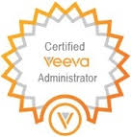
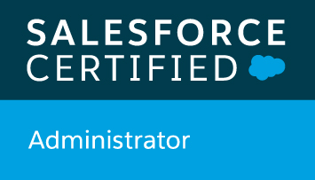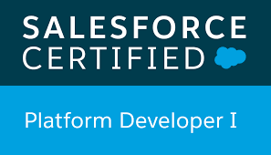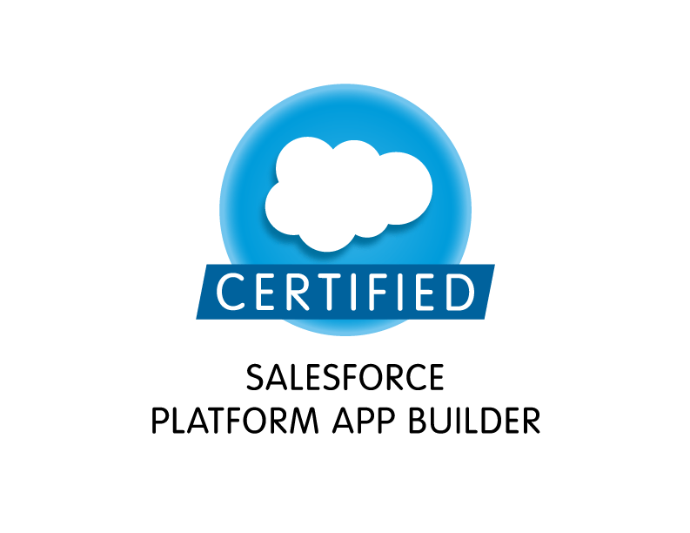

Khan
E-mail: sfdc012@gmail.com.
Contact: +91-9008732003.

Summary :

- Over 8 years of IT experience in various Technologies like Salesforce and Veeva development, enhancements, testing, and maintenance of Multi-tier, web-based and portals based object oriented enterprise applications.
- Extensively worked on various SFDC standard objects like Accounts, Contacts, Opportunities, Leads, Campaigns, Reports and Dashboards.
- Good Experience in developing Validation Rules, Work-Flows and Approval Processes for automated alerts, new Tasks, field updates, and Email generation according to application requirements.
- Experience in administration, configuration, Customization, Implementation, Data Migration and Support of Salesforce CRM.
- Extensively worked on various Veeva Objects like My-Accounts, Call, Cycle-Plan, Survey, Survey-Questions, Survey-targets, Products, Key-Messages, MCCP etc.
- Used Data Loader for insert, update, and bulk import or export of data from Salesforce.com Objects, from and into comma separated values (CSV) files.
- Implemented security and sharing rules at object, field, and record level for different users at different levels of organization.
- Experienced in Data Migration using Apex Data Loader.
- Created page layouts, search layouts to organize fields, custom links, related lists and other components on a record detail and edit pages.
- Experienced in training and mentoring team members with product knowledge and business processes.
- Strong work ethic, taking ownership of all duties and responsibilities and meeting management objectives.
- Able to perform all tasks related to the day-to-day operations including managing users, creating and maintaining custom objects and fields, handling data migration, maintenance of page layouts, and installation and support of AppExchange applications.
- Creativity and flexibility to face and resolve challenges, Good presentation skills and effective team player with excellent communication skills.

Educational Qualification : Master of Computer Application (M.C.A).

Certifications : 1. Salesforce Platform App Builder.
2. Salesforce Certified Administrator.
3. Salesforce Platform Developer-1 (PD1)
4. Veeva CRM Certified Administrator.

Employee Summary:

Currently Working in Infosys.

Worked as Team Lead in Accenture Service pvt Ltd.

Worked as Consultant in Capgemini Pvt Ltd.

Worked as a Software Engineering Analyst in Accenture Service pvt Ltd.

Worked as Software Developer in Elite Innovative Solutions.

Technical Skills :

SalesForce.com | Triggers, Custom Objects, Data migration, Record Types, Workflows, Email Templates, Visualforce, Apex, Dataloader, SOQL, SOSL,Chatter, Veeva.
Operating Systems | Windows 9x/2000, Win-XP, Windows Vista, Windows 7.
Languages and Scripts | JAVA , JavaScript, HTML, XML, CSS.
Database | MySQL, SQL Server, Oracle, MS Access.

Project#1: Novartis
Description: Linx is the Veeva instance for CRM in Europe. The system is based on Salesforce.com platform and uses their service cloud. Linx has 20 salesforce Orgs for various regions in Europe enabling the field force with different Veeva functionalities.

Role: Application Manager
Responsibilities:
- To ensure the right level of support as part of Service & Operations to all the users from different regions.
- Following the SOP’s in the Incident Management and Service Request as per the NBS-IT.
- Closely working with the Service Operations Expert in various project handovers and make sure the right transition to the Service & Operation team and Project Document List (PDL) validations and Project sign-off.
- First Point of Contact for Linx Application related issues and concerns to the Business Insight Managers of respective regions.
- Responsible for all the 20 Salesforce Production Orgs in terms of User Access Management, Audit trail Report and ensure changes within the scope of Service & Operations.
- Responsible for the Environment Management of Salesforce Orgs in terms of Data storage limit and Licenses.
- Interacting with Data Provider IQVIA for HCP and HCO’s values and DCR (Data change request) Updates.
- Monitoring the data flow from IQVIA to MDM and then to Veeva Application.
- Ensure the application support adheres all the IT-360 controls.
- Responsible for maintaining the System Life cycle documents with the updated functionalities.
- Ensuring the accurate resolutions delivered by the team on Service Request and Incidents with in the SLA’s.
- Closely working with the team members in resolution of tickets and helping them in technical and functional areas.
- Connecting with different stakeholder of the downstream and upstream applications.
- Responsible for the Impact Analysis of Veeva Releases w.r.t my application.
- Communicate to the business on the new Veeva and Salesforce releases with the impact Assessment report.
- Responsible for all the Change Request approvals within the application and ensure complete documentation in place as part of the change.

Role: SalesForce/Veeva Developer:
Project#2: One CRM

Description: Shire(Takeda) has implemented the Veeva CRM as its chosen Sales Force Automation (“SFA”)
solution and now plans to implement and deploy the Veeva CRM for its global sales teams in certain international markets in a project known as the Global CRM Roadmap Project (the “CRM Project”). As part of the CRM Project, Shire plans to deploy, replace and/or enhance current SFA solutions and applications with the Veeva CRM.

Responsibilities :

- Gathered requirements from business users and configured Profiles, Roles, workflows, Approval process, page-layouts.
- Involved in migrating data into salesforce application using apex data loader through CSV files. Installed and configured apex data loader.
- Responsible for Warranty and Production Support for all modules. Actively involved in resolving production issues.
- Extensively involved in deploying application to various environments.
- Taken the responsibility of deployment of different releases in project.
- Responsible for fixing up all post deployment fixes and different change requests.
- Responsible for Data model changes tracking and bridging gap between technical and business requirements.
- Configured and loaded Surveys for different regions as per business needs.
- Responsible for configuring call-Page layouts with different marker fields.
- Responsible for dealing with Roles, Profiles and system administrator activities.
- Responsible for mentoring new team members in talent transition and grooming them in all the areas of project.
- Involved in configuring reports (tabular, matrix, summary) and dashboards (call volumes, SLA related, case resolution timings etc).

Role: SalesForce/Veeva Support Analyst:

Project# 3: Medi Care

Responsibilities:

- Gathered requirements from business users and configured Profiles, Roles, workflows, Approval process, page-layouts.
- Interacted with the Salesforce.com premium tech support team on a regular basis.
- Responsible for configuring and enabling the Veeva functionalities like Cycle plan’s, Survey, call reporting, Meetings, Events Accounts and CLM.
- Responsible for Environment management of Veeva.
- Extensively involved in deploying application to various environments.
- Taken the responsibility of deployment of different releases in project.
- Responsible for fixing up all post deployment fixes and different change requests.
- Responsible for Data model changes tracking and bridging gap between technical and business requirements.
- Responsible for dealing with Roles, Profiles and system administrator activities.
- Responsible for Survey Management in Veeva for all the AZ Markets across the globe
- Responsible for Product setup to the users based on the business needs.

Role: SalesForce/Veeva Support Analyst:

Project#4: IMCM-Bayer

Responsibilities:
- Implemented pick lists, dependent pick lists, lookups, master detail relationships, validation Rules and formula fields to the custom objects.
- Created page layouts, search layouts to organize fields, custom links, related lists, and other components on record pages.
- Responsible for Product setup with Key Messages to the users based on the business needs.
- Used field level security along with page layout to manage the visibility and accessibility of fields for different profiles.
- Create workflow task time based Alert and email alert notification with approval process.
- Created various reports (matrix reports, pie charts, dashboards) and setup report folders.
- Imported data from excel sheets in to MyAccounts, Survey, Questions, Survey Targets using Data Loader and Workbench.
- Documented CDD (Configuration Design Document) for Developers to implement in Production Environment.
- Created Commit Slides for each request before release for end users Training.
- Performed Unit testing in implementation.
- Enabled Approved email functionality for various markets
- Added custom fields to objects like MyAccounts, Meetings, Survey’s, Cycle Plans.
- Implemented the requirements on Salesforce.com platform and Force.com IDE Plug-in using Eclipse.
- Developed various Custom Objects, Tabs, Components and Visual Force Pages and Controllers.
- Developed and configured various Custom Reports and Report Folders for different user profiles based on the need in the organization.

