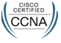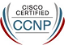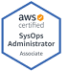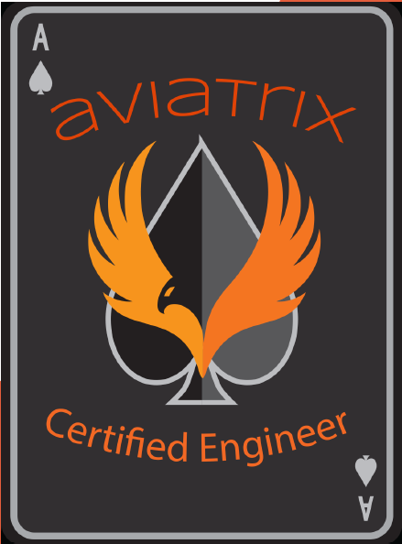
Resume
Mahendar Reddy K Email: mahendarec@gmail.com
Phone: Ph1-9666601665/Ph2-7019318583
Professional Experience:
- Currently I am working as “Senior Network Engineer” for Capgemini since May-2021 with total 10 years of experience.
- Hands on Routers, Switches, F5 load Balancer, Wireless LAN, Riverbed and ASA Firewall, Check point firewall, Cisco Meraki, Cisco ISE, Solar winds.
- Good experience about ITIL process and experience on HP SM7, Remedy, ServiceNow, Cherwell ticket tools.
Technical Certifications:
- CCNA-CSCO12513552, CCNP Switch, AWS SysOps and Aviatrix certified on Multi-Cloud Networking.
Education:
I have completed my B. Tech E.C.E from JNTUH in the year 2011.
Technical Skills:
- Services : Telnet, SSH, HTTP, HTTPS, and FTP.
- Switches : Cisco Switches 2960,3550,3750, C3850,4506 and N7K, N9K.
- Routers : Cisco Routers 841M,1800,7206,1000ASR Routers.
- Routing Protocols : Static, BGP, EIGRP and OSPF.
- Switching Protocols : VLAN, VTP, STP, Vpc, VSS and Port-Channel.
- Internet Protocols : ARP, HSRP, TCP, UDP, TFTP, DNS.
- Networking Resources : Routers, Switches, Printers, F5 LB, Wireless LAN.
Employment History:
Capgemini May 2021 to Till Now.
- Working on BGP, EIGRP, ACL, IPsec configuration and troubleshooting.
- In day to day, I am working on troubleshooting network slowness issues, troubleshooting reachability issues, working on Cisco ASA VPN, policies, configuring the cisco and Meraki switches and troubleshooting the Meraki AP issues, working on McAfee and troubleshooting site access related issues, configuring the F5 LTM LB and troubleshooting the issues.
- Working on Cisco IOS switches upgradations 2960,3560,9300 models, also working on Meraki switches and AP’s upgradations.
- Working on TACACS, AAA, SNMP configurations and troubleshooting.
- Working on Net scalar load balancer.
- Working on ASA firewall.
- Certified in AWS and AVI Aviatrix Multi-cloud.
- Working on Check Point firewall.
- Working Cisco Meraki switches and Access Points.
- Working on Cisco ISE.
Accenture Solutions Pvt.Ltd. March 2017 to May 2021
- Configuring and troubleshooting the BGP, EIGRP and OSPF Protocols.
- Working on DHCP servers like creating scope, reserving IPs with MAC, deleting the IP reservations.
- Configuring and troubleshooting ISP links and coordinating with vendors according to the issues.
- Configuring and troubleshooting F5 LB LTM part.
- In day to day troubleshooting issues like slow network, site access, server reachability/connectivity related issues and shared folder related issues.
- Troubleshooting wireless related issues like WAP down, connectivity related issues and WLC issues.
- Troubleshooting switching related issues like PO/EtherChannel, Vpc and VSS.
Dimension Data India Pvt.Ltd. From April 2016 to March 2017.
- Enabling the HTTP, HTTPS, TCP, UDP, ADS, FTP ports for required sites as per the client requirement.
- Analyzing the client provided error logs and troubleshooting accordingly, also understanding the router, switches, and F5 LB logs as part of troubleshooting.
- Allowing / Denying the sites by creating the ACL as per the client requirement.
- Configuring the Crypto, ACL, SNMP and troubleshooting the issues.
- Configuring the QoS in routers and switches.
- Troubleshooting the connectivity issues by ping, traceroute, config between the branches, LHO, DC & DR locations and troubleshooting the routing and switching issues.
- Configuring the new WAN links on router interfaces and configuring and troubleshooting the BGP and coordinating with the SP till issue resolution.
- Configured different technologies like VSAT at remote location branches also configured the tunnels at DC, DR and troubleshooting the issues also checking with VSAT vendors till the resolution.
- Configuring the ISDN at LHO and branches end and fixing the issues.
- Configuring the vlans and troubleshooting according to the issues.
- Understanding the branch utilization by IP accounting logs, BW utilization reports, troubleshooting accordingly.
Prolink Computers Pvt.Ltd. From October 2015 to March 2016.
- Hands-on troubleshooting Cisco and HP routers and switches.
- Handling the core routers and switches of DC & DR.
- Creating and troubleshooting of the VPN users and client software.
- Maintaining the weekly, monthly backups of routers and switches also upgrading the IOS versions.
- Creating the tunnels at DC, DR, branches and troubleshooting the issues.
CMC Limited. From March 2014 to June 2015.
- Network maintenance, monitoring and troubleshooting software and hardware related issues.
- Responding to outages and working closely with the NOC operations.
- Troubleshooting the application and server related issues.
- Troubleshooting the internet and LAN problems.
Value Point Systems Pvt.Ltd. From December 2012 to March 2014
- Troubleshooting the internet and intranet, LAN issues.
- Installing and configuring the cisco routers 2500,2600,3845.
- Troubleshooting enterprise application response problems & Connectivity issues.
- Had good experience on remote tools like VNC, DAMWARE, Team Viewer, Zoom and WebEx.
Astersys technologies. From October 2011 to November 2012.
- Assembling & troubleshooting of systems, software & Patches installations.
- Installation of workstations, creating users, configuration of outlook and troubleshooting.
- Application troubleshooting like MS Office, VPN, and all types of OS.
- Installing Citrix client application and testing the VDI environment on the user desktop/laptop.
- Creating profiles for users, customizing the desktop settings and domain setup.
- MS outlook configurations files troubleshooting, moving PST files and adding into the account.
- Administration and troubleshooting of video conference equipment.

