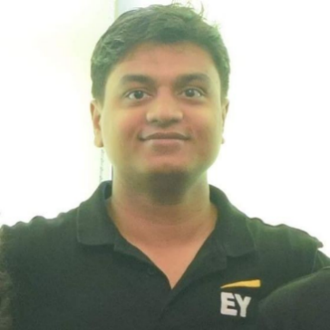 **PRAKASH KUMAR SINGH**

+91-7975589940

prakash.kumarsingh428@gmail.com

………………………………………………………………………………………………………………………………………………………………....

**PROFESSIONAL SUMMARY**

Software Development Engineer, with an experience working in the business of Insurance using latest technology tools, focused on integration aspect of business and software, having a passion and zeal for latest technologies.

………………………………………………………………………………………………………………………………………………………………….

**SKILLS & KONWLEDGE AREAS**

**Business Domain:** Insurance | Claims

**Software Packages:** 1. MuleSoft  
 2.GuideWire | Portals & Claim Center - Integration   
**Databases:** MS-SQL

**Programming Languages:** Java | GOSU | JavaScript | Angular JS | HTML | C++

………………………………………………………………………………………………………………………………………………………………….

**WORK HISTORY**

10/2017 to 09/2019 Associate Software Engineer

***Ernst & Young Global Delivery Services LLP*** – *Chennai*

* Worked on performance enhancement and code optimization to process large set of data points using MuleSoft.
* Developed Batch process using MuleSoft.
* Implemented a sophisticated error handling and reconciliation mechanism for Batch process.
* Had been a key resource in implementation of SCIM standards which were required to integrate GuideWire Contact Manager and Azure Active Directory
* Implement error and file duplication tracking for Bank integration.
* Implemented security enhancement of services exposed requiring client id and security certificates.
* Worked on integration of various systems using MuleSoft/CloudHub vis-à-vis Guidewire and various other systems using SOAP service, xml, text, etc.
* Worked on SQL Scripts for Data Access such as selection, Insertion and Deletion, Joins of Data from MS-SQL Databases.
* Added functionalities to applications using Java and J2EE technologies.
* Worked on GuideWire Portals and Edge Layer of GuideWire Claims Center using GOSU and web technologies such as Angular JS, JavaScript and HTML.
* Implemented integration of Portals and GuideWire with ThunderHead services.
* Worked in Agile SDLC (Software Development Life Cycle) process.
* Providing End to End support for the testing activities during System Testing.
* Have delivered tasks in shorter than expected time period with very few to no defects.
* Ability to work in large/complex projects involving teams in different locations & taking bottom line responsibility of the tasks assigned.

……………………………………………………………………………………………………………………………………………………………....

**Appreciations**

* Awarded twice with Spot Awards
* Received appreciations from the client and team seniors for speed delivery of tasks with minimum defects.

………………………………………………………………………………………………………………………………………………………………….

**Soft Skills**

Good Interpersonal skills | Good communication skills | Teamwork | Idea generation & Exchange | Coordination with international teams | Problem Solving

………………………………………………………………………………………………………………………………………………………………….

**Additional Knowledge Areas**

Embedded C | Marketing Management | Concept of Block Chain | Basics of CORDA | GuideWire Suite | Business of Insurance

………………………………………………………………………………………………………………………………………………………………….

**DECLARATION**

I hereby declare that the above-mentioned information is true to the best of my knowledge and belief.

**Place: Chennai**

**Date: Jan 2021**