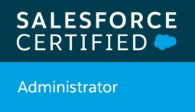

Personal Details

Contact : +919810471267

Email: [salesforcedelhi@gmail.com](mailto:salesforcedelhi@gmail.com)

Current location: C-7/199

keshav puram

delhi 11035

Relocation – Willing to Relocate

Comfortable working 24X7 environment

Comfortable working on weekends

**SUMMARY**

A highly energetic, motivated sales passionate professional, with a desire of working with a fortune 500 company in a Technology Sales environment. Presenting technology solutions is what makes me feel happy. Also, recently cleared my Salesforce Administrator Certification with 2+ years of Moonlighting experience on developer.salesforce.com (Salesforce Sandbox environment). Skilled in creating functional dashboards and reports. A very passionate and active Member of the Salesforce trailhead community with a total of 62 badges and 48000 points till date.

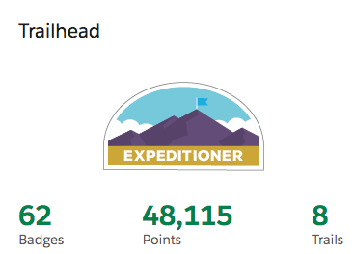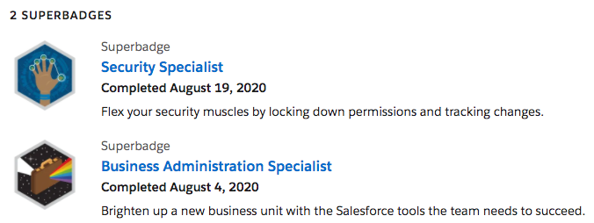

**SALESFORCE SKILLS**

• User Management• Access Management • Salesforce Administration• Roles and Sharing Rules •Profiles and Permission Sets • Workflows • Approval Processes • Process Builder • Security Setup • System monitoring • Clean up • Data management • • Documentation & Reporting • Process Optimisation • Software/Application Development • Salesforce Configuration • Salesforce Support • Training • Solutions Development• Chatter

trailhead link: <https://trailblazer.me/id?lang=en_US>

WORK EXPERIENCE:

**11/Nov2019 – 28/Feb2020 – Wunderman Thompson/MSC (client: Microsoft)**

**Title : Sr. Analyst (campaign execution)**

**Responsibilities:**

* Work on UI based platforms to set-up digital events, basis the event specification received from requestor.
* Self review the output and share for review/approval. Make sure the deliverable is as per the defined quality standard
* Adherence to all the required processes, checklist and service level.
* Communication with internal/external stakeholder for campaigns
* Flag risks to operations head if needed or identified during the course of operations
* Accountability for resolving client issues and escalating to the appropriate person to the point of resolution
* Understanding requirement from client on calls, performing required actions.

**Sept/2016 – june/2019 – Powerage Wires and cables**

**Title : Marketing and sales executive**

**Responsibilities:**

* Marketing solution sales in PAN India market.
* Conducting market research to identify selling possibilities and evaluate customer needs
* Actively seeking out new sales opportunities through cold calling, networking and social media
* Setting up meetings with potential clients and listening to their wishes and concerns
* Client handling and and lead generation
* Account management
* Major clients: Wipro, Quattro, Mankind

**June/2014 – Jun/2016 – Iyogi technical Services**

**Title : Technical Sales Executive (MAC Tech Sales)**

**Responsibilities:**

* Customer Service for US/UK and AUS market for apple products
* Technical sales for annual support subscription for apple products
* Technical troubleshooting of apple devices
* Communication training, team handling
* Salesforce CRM

**Technical Skills and tools**

Certain, Marketo, Salesforce, Basic HTML, MS office, on24, Mash, Power BI,

Apple devices troubleshooting,

**Qualification, Certification and training**

* 10th CBSE (2008)
* 12th CBSE (2010)
* Graduation –Bsc IT (Sunrise University Alwar) (2015)
* **Salesforce Certified Administrator – 21598161**
* **MBA essentials Drucker School (Salesforce trail)**