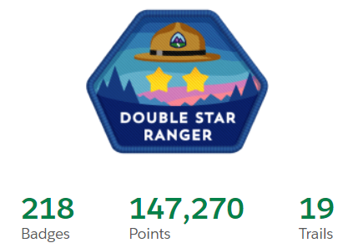
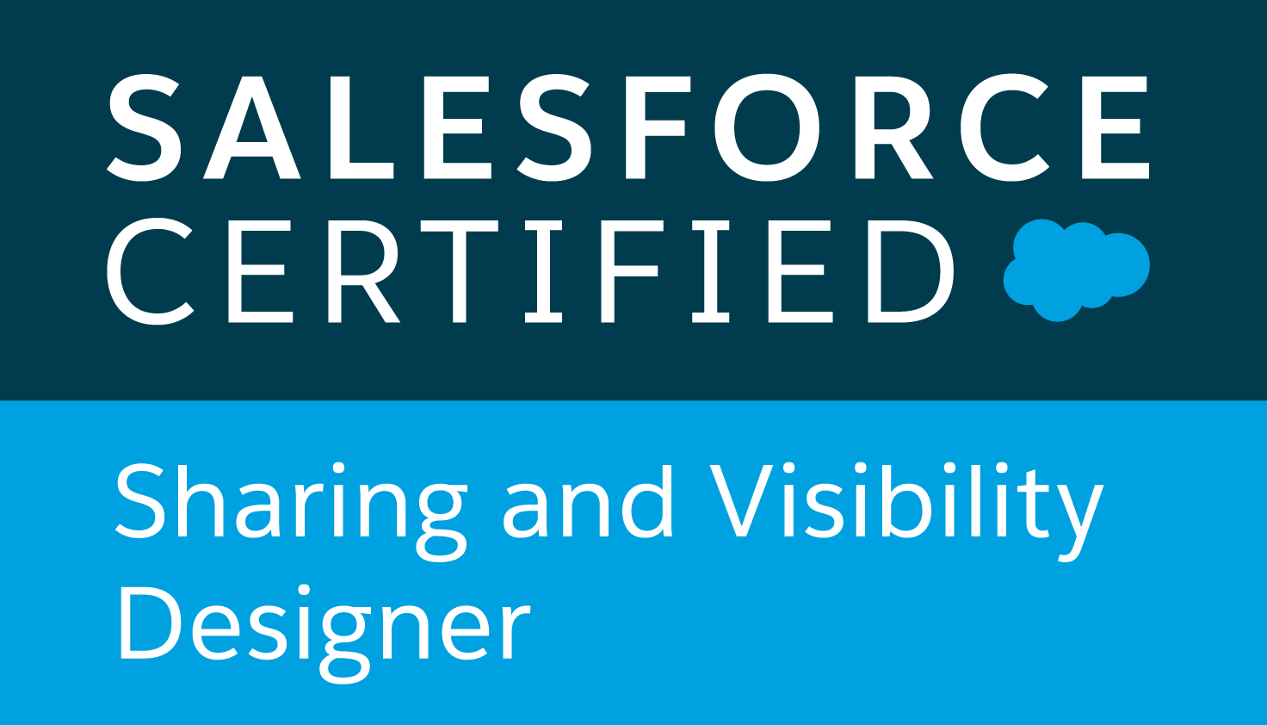
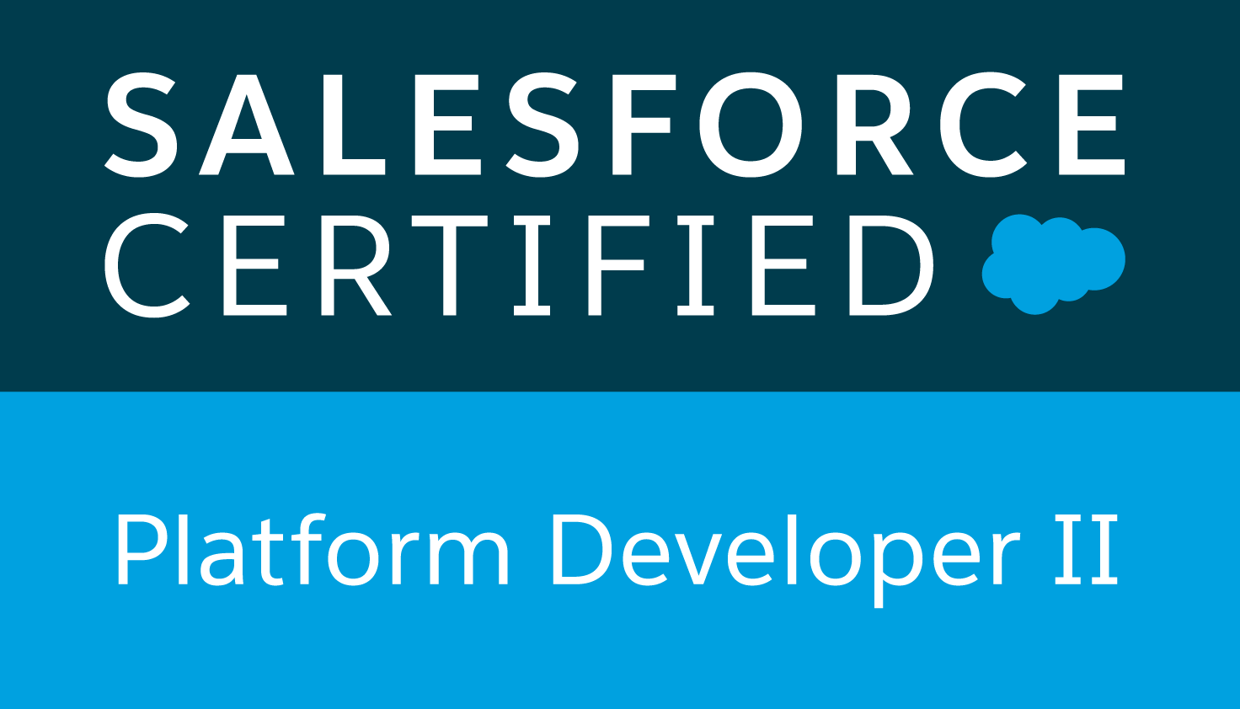
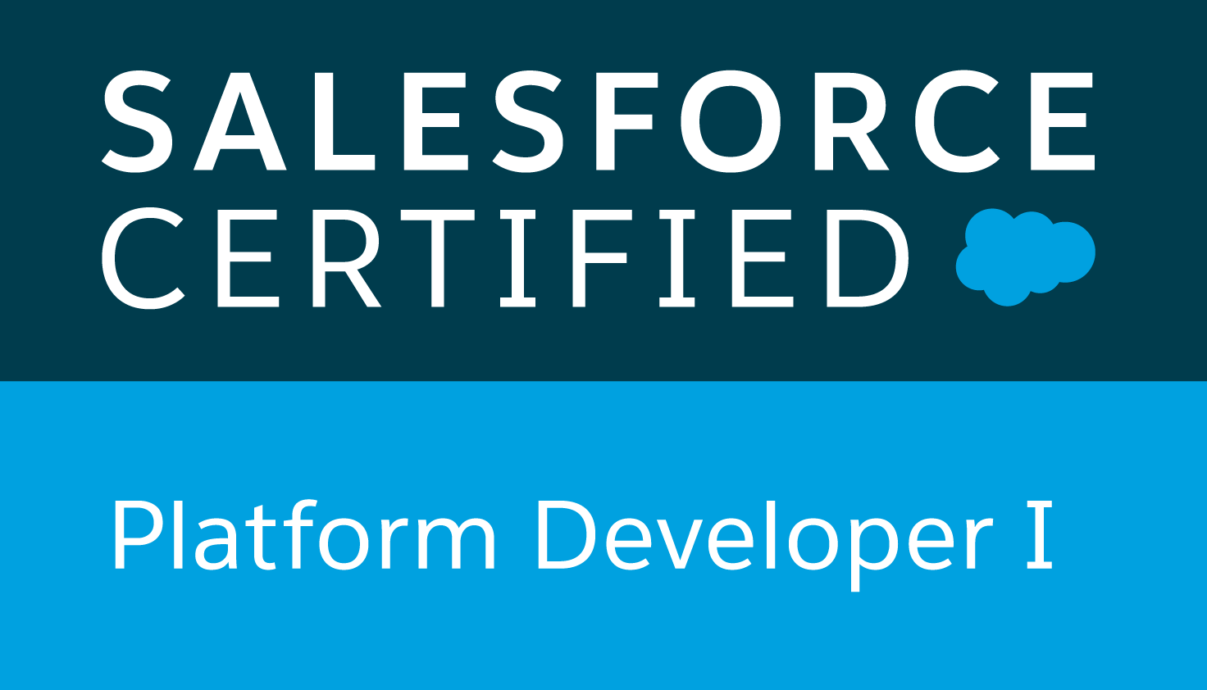
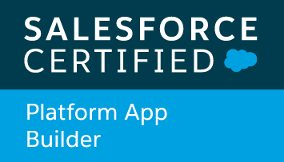
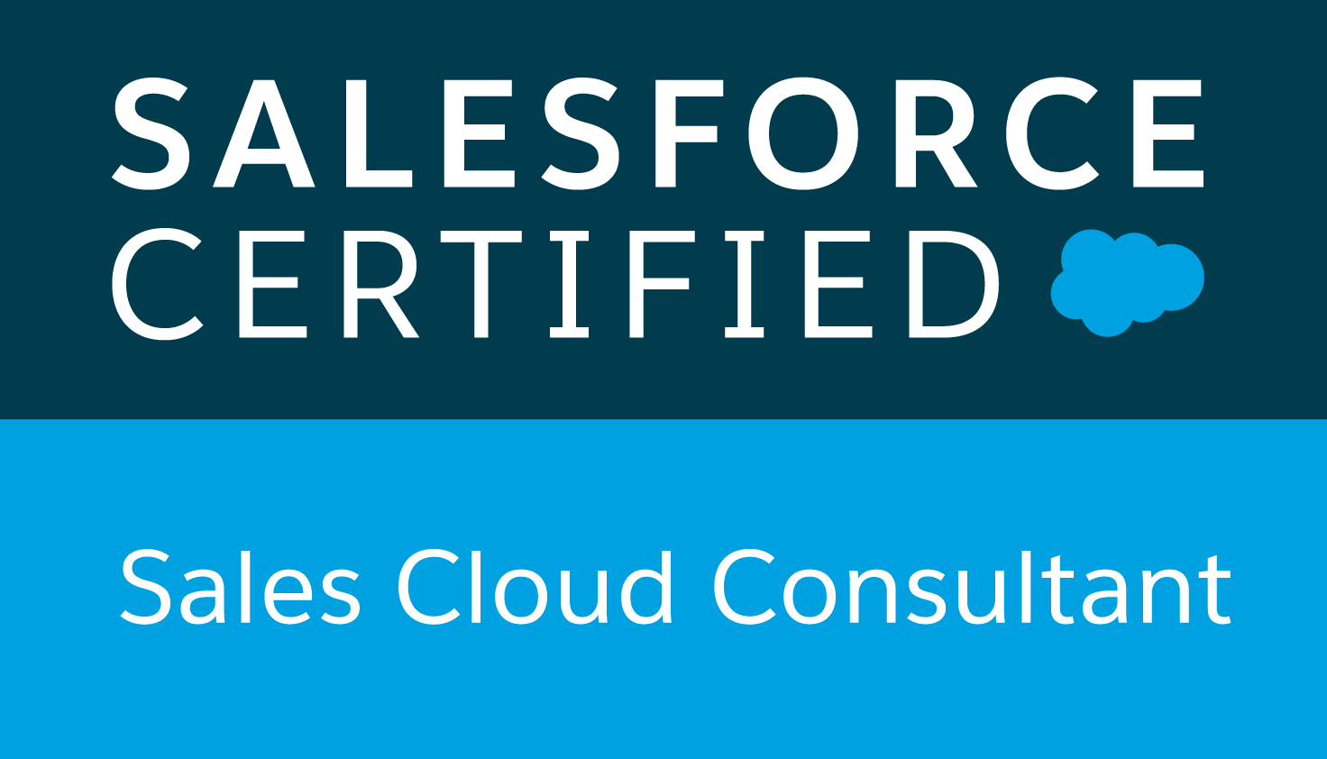
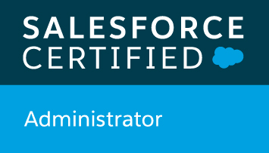
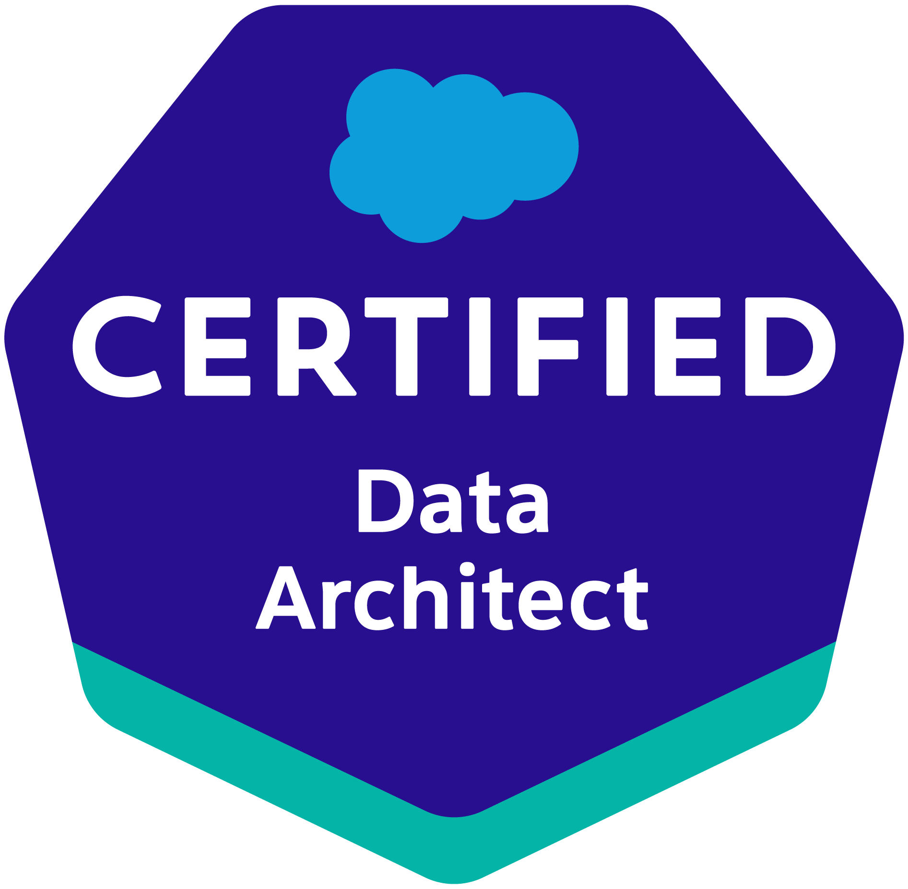
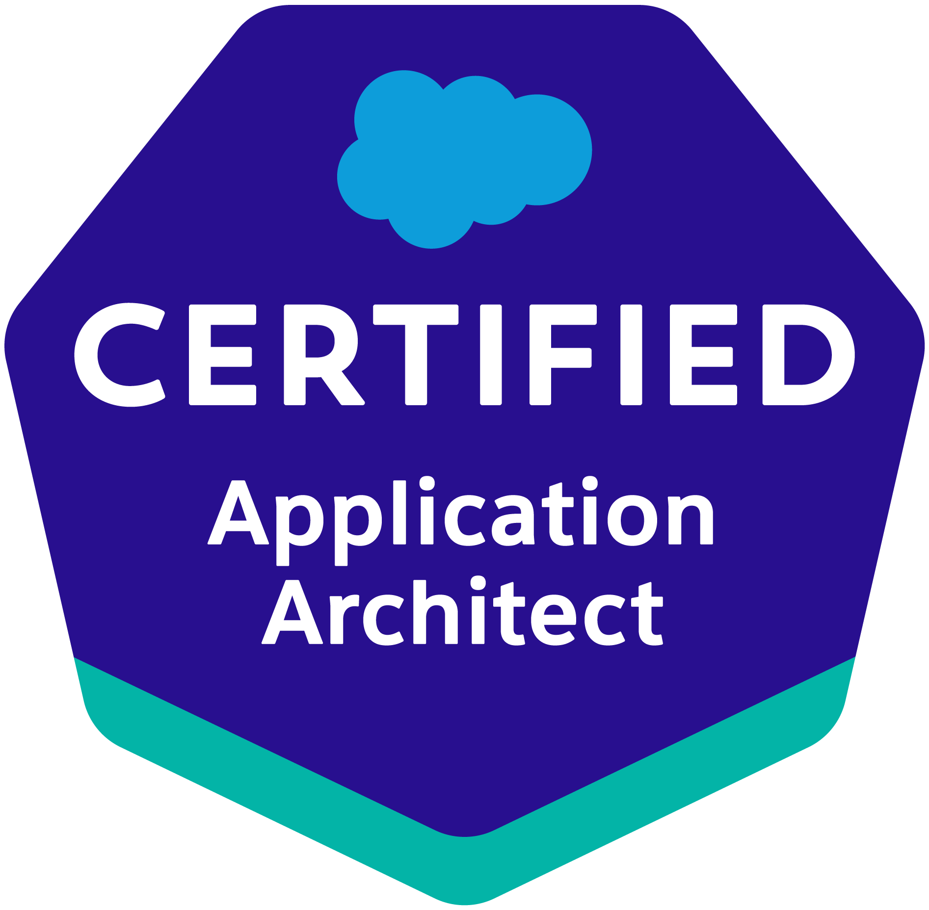
ANBU M. SUKANTA
Phone: +91-9940031367
E-Mail: sukanta.manimaran@gmail.com
EXPERIENCE SUMMARY
Lead Consultant with 4+ years of IT experience in SDLC, Agile/Scrum methodology and Waterfall methodology. 8X Certified Salesforce Application Architect and Developer and Sales Consultant with certifications in Sales Cloud, Sharing and Visibility Designer, Data Management & Designer, PDII, PD1, App Builder and Admin and 2X Ranger in Trailhead with 9 Super Badges. Involved in Apex Classes, Apex Triggers, Apex Scheduler, Batch Apex, Aura Components and Visualforce pages and Integration (HTTP callout and REST API). Adept at Business Requirement Gathering and Analysis, Application Design, Development and Architecture, Client Interfacing, Project Co-ordination. Experienced in designing Security like Authentication and Authorization (Object level, Field level and Record level security) and Salesforce Admin skills (Reports & Dashboards, Automations, Page layouts, Object Management, etc,).
EDUCATION:
- B.Tech (Energy and Environmental Engineering) with 83% from Tamil Nadu Agricultural University (2008-2012).
- M.E. (Solar Energy) with 86.5% from Anna University, Chennai (2012 - 2015).
WORK EXPERIENCE:
- Associate Senior Consultant at Amtex Software Solution Pvt Ltd., from September 2019 to till date.
- Programmer Analyst at Srinsoft Technologies Pvt Ltd., from April 2018 to March 2019.

TECHNICAL SUMMARY:

- Development tools/IDE: Eclipse IDE, Oracle’s SQL Developer, Force IDE, Force.com (Apex, Triggers, Batch Apex, Scheduler Apex, SOQL, SOSL, Aura Components, Lightning Web Components, Visual Force pages, Dashboards, report backup, Admin skills including Automation, security, Object and App Management), Developer Console.
- CRM: Salesforce
- Cloud: Sales Cloud, Service Cloud
- Integrations: Integration using HTTP callouts, REST API & Web Services (Heroku, Jitterbit, Bhoomi Atom)
- Programming Languages: Apex, Core Java (OOPS), Advanced Java J2Ee (Servlets and JSP)
- User Interface: JSP, HTML, CSS, jscript, jquery
- Source Control (SCM): SVN
- Database: Oracle SQL, My SQL
- Frameworks: Spring Core, Spring MVC, Hibernate
- Methodologies: SDLC, Agile/Scrum methodology, Waterfall methodology
PROJECT SUMMARY

- HRMS – Talent Acquisition Portal
Roles & Responsibilities:
- Developed Visualforce Pages for various Custom objects with different functionalities using Apex Classes and Apex triggers, SOQL and SOSL.
- Used Test classes for Triggers and Apex cases.
- Used SVN for Version control and deployed using Change Sets and Unmanaged packages.
- Involved in Data Management, Configuration and creating Reports and Dashboards.
- Involved in Requirements gathering.
Environment : Salesforce.com
Client : Srinsoft Technologies, HR Team.
Tools : Salesforce.com
Role : Software Developer

- WEXI Web Application and Website
Roles & Responsibilities:
- Involved in Requirements gathering and analysis, preparation of HLD, LLD, Resource planning etc,.
- Worked as a Component Developer using Java and J2EE, CSS, HTML, JScript and Jquery.
- Have performed Unit Testing and involved in Deployment.
- Involved in Scrum management
Environment : AS400, Eclipse
Client : West End Express, US
Tools : Spring MVC, Eclipse, Core Java, JScript, JQuery, Servlets, Apache Tomcat Server 7, AS400
Methodology : Agile
Role : Software Developer

- ESTES EXPRESS LINES, USA
Roles & Responsibilities:
- Used Apex Batch classes and Apex scheduler for Job monitoring, Bill monitoring etc,.
- Used Visualforce pages, Page Layouts, salesforce.com for User interface.
- Worked with Apex classes, Triggers for meeting various custom functionalities in custom & standard objects
- Involved in Data Management and Warranty Support.
Environment : Salesforce.com
Client : Estes Express Lines, USA
Tools : Salesforce.com
Role : Software Developer

- Club Registration Application(Enhancement)
Role & Responsibilities:
- Designed user interface using VF pages (for list view).
- Integration between on-prem Database and SFDC using php and REST callouts in php My Admin.
- Designed and built functionalities using Apex, triggers, SOQL.
- Involved in Automation using Process Builder, Workflow, Email templates, Validation Rules, etc.
Environment : Salesforce.com
Client : UNICEF
Tools : Salesforce.com, php MyAdmin, mySQL
Role : Senior Developer

- Claim Reimbursement Application
Role & Responsibilities:
- Created User Interface with different functionalities using Visualforce pages and Apex classes and Apex triggers.
- Involved in creating automated flows using Workflows, Process builders and Approval process for Claim submission, Approval/rejection and mail intimation in every step of the process.
- Involved in unit test and writing test Class for Apex classes and triggers.
- Deployment to Production using Change sets.
Environment : Salesforce.com
Client : Amtex Software Solutions, Finance Department.
Tools : Salesforce.com.
Role : Senior Developer and Tech Lead

- Document Management Solutions
Role & Responsibilities:
- Designed user interface using Lightning or Aura Components, VF pages (for list view) Apex Classes.
- Designed and built functionalities using Batch Apex, Scheduler Apex, triggers, SOQL, HTTP POST and GET callouts for multi-type file upload, Bulk download (more than 3000 documents or PDF or images, excel, etc) of files from external container.
- Designed the Architecture for the flow between SFDC and Rackspace and devised the solutions with Objects and fields, automation and security for the Application.
- Involved in integration with PostgreSQL and Rackspace for external storage using Heroku.
- Deployment to Production using Unmanaged package and Change sets.
Environment : Salesforce.com, Heroku, PostgreSQL and Rackspace (external container for document storage).
Client : TKC Holdings, USA
Tools : Salesforce.com, Heroku, PostgreSQL and Rackspace.
Role : Senior Developer and Tech Lead

- Deduplication and Data Management
Role & Responsibilities:
- Designed user interface using Lightning or Aura Components, VF pages (for list view) Apex Classes.
- Designed and built functionalities using Batch Apex, Scheduler Apex, triggers, SOQL.
- Designed the Architecture for the flow between SFDC and Rackspace.
- Involved in Automation using Process Builder, Workflow, Email templates, Validation Rules, etc.
- Deployment to Production using Unmanaged package and Change sets.
Environment : Salesforce.com, Heroku, PostgreSQL
Client : SDI Inc, USA
Tools : Salesforce.com, Heroku, PostgreSQL
Role : Senior Developer and Tech Lead

- Salesforce to SharePoint Integration
Role & Responsibilities:
- Involved in building requirement Analysis, identification of connectors and creating Architecture.
- Responsible for automation of the functionality to trigger a connector in response to button event in SF using Flows to prepopulate values in SharePoint.
- Responsible for building Flow in Microsoft PowerApps for integrating SF with SharePoint.
- Involved in getting response to store in a Log object in SF.
- Responsible for Notification logic using Process builder after record is created in SharePoint
Environment : Salesforce.com, SharePoint, Microsoft PowerApps
Client : TKC Holdings, USA
Tools : Salesforce.com, SharePoint, Microsoft PowerApps
Role : Senior Developer and Tech Lead

