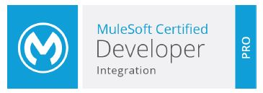
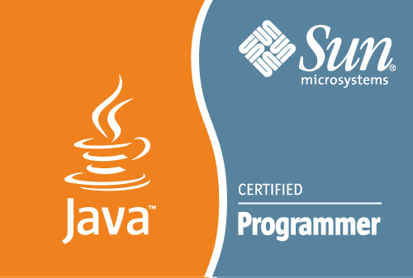
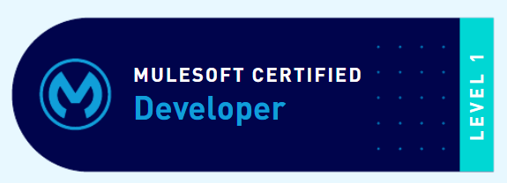

S SYED
E-Mail: syedmulesoft2030@gmail.com
Result-oriented professional targeting assignments in MuleSoft Application Design & Development and Team Management with an organization of repute in IT industry, preferably in Hyderabad

PROFILE SUMMARY
- Achievement-oriented professional with nearly 8 years of experience (6 years in MuleSoft) Application Design & Development
Key Skills:
Application Design & Development
Technical Support
Technical Documentation
Application Migration
Requirement Gathering
Team Management

- Worked as Specialist in MuleSoft Anypoint Platform Technologies on Cloud and on-premise
- Expertise for defining application migration & deployment strategy on Cloudhub, performing capacity planning and identifying Cloud PaaS services leveraged in application re-factoring
- Contributed many Technical blogs, Youtube videos and live Demos
- Received Spark Award every year for best performance
- An excellent communicator with exceptional interpersonal and problem-solving skills with flexible attitude

WORK EXPERIENCE

Role:
- Providing technical solutions/designs to project execution teams for implementation
- Providing technical assessments, strategies and roadmaps for one or more technology domains
- Working with Application Developers, Users, Operational Leadership and Subject Matter Experts to understand current & future operational data analysis goals
- Developing and maintaining data integration strategy and highlighting risk & opportunity areas associating them with business impact
- Owning data integration platform to ensure that it meets current business needs and plan for future growth
- Leading work stream or act as a team lead and managing non-complex components of the work plan/project
- Utilizing analytical, process, and/or technical skills to meet project objectives & deliverables self-directed and within project scope

Highlight:
- Received Spark Award every year for best performance
- Best Technical Blocks writing, live Demos and Youtube videos
- Successfully completed delayed projects essential for operational efficiency by identifying and solving complex technical problems using interdisciplinary teams
- Delivered presentations and demos and imparted technical trainings to freshers
- Provided production support to team in application release

PREVIOUS EXPERIENCE

Sep’19-till date CloudAPI as MuleSoft Consultant

Mar’15-Sep’19 Coforge Hyderabad, Telangana as Technical Specialist

Growth Path:
Mar’15-Mar’17 Software Engineer
Apr’17-Oct’18 Sr. Software Engineer
Nov’18-Sep’19 Technical Specialist

EDUCATION

MCA from Osmania University

CERTIFICATIONS

- MuleSoft Certified Developer – Level 1 (Mule 4)
- MuleSoft Certified Developer - Integration Professional Mule3.x - expired
- MuleSoft Certified Developer - Mule 3.x -expired
- MCD - API Design Associate (RAML 1.0) - expired
- SCJP - Sun Certified Java Programmer-expired

IT SKILLS

MuleSoft Anypoint Platform: API Designer, API Manager, Anypoint Exchange, Anypoint MQ, Anypoint Studio, Mule Runtime -3.6 to 4.2, API Security OAUTH, SSL, SAML, Munit
Other Technologies: REST and SOAP Web Services, Java, J2EE, Spring MVC, Struts 1.x, JMS, PostgresSQL, MYSQL, SOAP UI, Ajax, HTML, SQL, PL/SQL, SVN, GIT, XML, JSON, Jenkins, Maven, Tomcat, JBoss, Windows, Linux & Mac

PROJECTS MANAGED:
PROJECT 1
Title: Kroger Integration
Environment: Mule 4.x, Anypoint Platform, Anypoint Studio, SqlServer DB & GIT
Team Size: 6
Duration: Apr 2022 – Dec 2022
Role: Senior MuleSoft Developer
Description: Under this project, MuleSoft integrated their enterprise system and migration of legacy system which increased the business
Role:
- Conducting workshops to understand the existing system and Requirement
- Document the Low Level Design and mapping contracts
- Design RAML and Manage the APIs
- Create the code repository and project structure for all Mule APIs
- Assigned task to Developers and resolved technical issues and explain the project business requirement to the team
- Managed code review, merge and deploy the MuleSoft applications in Cloudhub (Anypoint Platform)
- Manage APIs, Proxy End points, API portals

PROJECT 2
Title: Brilliant Basic pricing (Phase 1, Phase 2, Phase 3)
Environment: Mule 4.x, Anypoint Platform, Anypoint Studio, SqlServer DB & GIT
Team Size: 5
Duration: Mar 2021 – Feb 2022
Role: Senior MuleSoft Developer
Description: Under this project, MuleSoft integrated their enterprise system and migration of legacy system which increased the business
Role:
- Conducting workshops to understand the existing system and Requirement
- Document the Low Level Design and mapping contracts
- Design RAML and Manage the APIs
- Create the code repository and project structure for all Mule APIs
- Assigned task to Developers and resolved technical issues and explain the project business requirement to the team
- Managed code review, merge and deploy the MuleSoft applications in Cloudhub (Anypoint Platform)
- Manage APIs, Proxy End points, API portals

PROJECT 3
Title: FirstPort Retirement Property Services Limited
Environment: Mule 4.x, Anypoint Platform, Anypoint Studio, SqlServer DB & GIT
Team Size: 4
Duration: Sep 2020 – Dec 2020
Role: Senior MuleSoft Developer
Description: Under this project, MuleSoft integrated their enterprise system and migration of legacy system which increased the business
Role:
- Conducting workshops to understand the existing system and Requirement
- Document the Low Level Design and mapping contracts
- Design RAML and Manage the APIs
- Create the code repository and project structure for all Mule APIs
- Assigned task to Developers and resolved technical issues and explain the project business requirement to the team
- Managed code review, merge and deploy the MuleSoft applications in Cloudhub (Anypoint Platform)

PROJECT 4
Title: Policy Reactivation
Environment: Mule 4.x, Anypoint Platform, Anypoint Studio, SqlServer DB & GIT, Urban Code (CI/CD)
Team Size: 2
Duration: Oct 2019 – July 2020
Role: Senior MuleSoft Developer
Description: Under this project, MuleSoft replaced the existing ESB (Microsoft Biztalk) for their enterprise system which increased the business.
Role:
- Conducting workshops to understand the existing system and Requirement
- Involved in Design MuleSoft API LED connectivity Architecture
- Document the Low Level Design and mapping contracts
- Design RAML and Manage the APIs
- Create the code repository and project structure for all Mule APIs
- Developed MuleSoft APIs
- Deploy the MuleSoft applications in Cloudhub (Anypoint Platform)
- Support the application till go live and warranty support

PROJECT 5
Title: BMX System Integration (Phase 1 and Phase 2)
Environment: Mule 4.x, Anypoint Platform, Anypoint Studio, SqlServer DB & GIT
Team Size: 5
Duration: Nov 2018 – Aug 2019
Role: Senior MuleSoft Developer
Description: Under this project, MuleSoft integrated their enterprise system and migration of wiggle and CRC which increased the business in UK & other countries.
Role:
- Reviewed SDD documents and mapping contracts
- Create the code repository and project structure for all Mule APIs
- Assigned task to Developers and resolved technical issues and explain the project business requirement to the team
- Managed code review, merge and deploy into ARM
- Developed common components (Logging, Auditing and Exception Management)

PROJECT 6
Title: Bata System Integration (Phase 1)
Environment: Mule 3.x, Anypoint Platform, Anypoint Studio, SFTP & GIT
Team Size: 10
Duration: June 2018 – Oct 2018
Role: Senior MuleSoft Developer
Description: Under this project, MuleSoft integrated their enterprise system migration which increased the business in Italy, Czech Republic & other countries.
Role:
- Designed API designer, prepared SDD documents and mapping sheets
- Developed complex services
- Managed code review, merge and deploy into ARM
- Developed common components (Logging, Auditing and Exception Management)
- Actively participated in workshops with client & vendors

PROJECT 7:
Title: Suez System migration (Phase 1 to 4)
Environment: Mule 3.x, Anypoint Platform, Anypoint Studio, SAP, GIT & Jenkins
Team Size: 12 members
Duration: Sep 2016 – May 2018
Role: MuleSoft Developer (Team member)
Description: Under this project, MuleSoft integrated their enterprise system migration increasing business in UK and other countries.
Role:
- Developed mule flows
- Conducted unit testing with Munits and provided SIT, UAT and Production support

PROJECT 8:
Title: C Hoare Bank Digital Banking Platform Integration (Phase 1)
Environment: Mule 3.x, Anypoint Studio, Jenkins, Maven, SIT
Team Size: 9 members
Duration: Sep 2015 – June 2016
Role: Mule Developer (Team member)
Description: C Hoares Bank (call it CHC) chose MuleSoft ESB technology to address integration challenges around the implementation of the new digital banking solution.
Role:
- Develop Mule flows
- Integrated modules and conducted unit testing with tools
- Deployed the Mule Application in MMC

PROJECT 9:
Title: Navision Google Calendar Integration
Environment: Mule ESB, Anypoint Studio 3.6, Salesforce, Google Calendar, AmazonS3 & Maven
Team Size: 2 members
Duration: June 2015 – Aug 2015
Role: Mulesoft Developer (Team member)
Website: www. rentokil-initial.com
Description: The Rentokil Initial organization provided services protecting people and enhancing lives. It protected people from the dangers of pest-borne disease, the risks of poor hygiene or from injury in the workplace. It enhanced lives with services protecting health & well-being of people and reputation of their customer’s brands. The Navision Google Calendar Integration project integrating data between Navision & Rentokil Systems through Mule ESB and different systems.
Role:
- Integrated modules and conducted unit testing with tools
- Deployed Mule application in MMC

