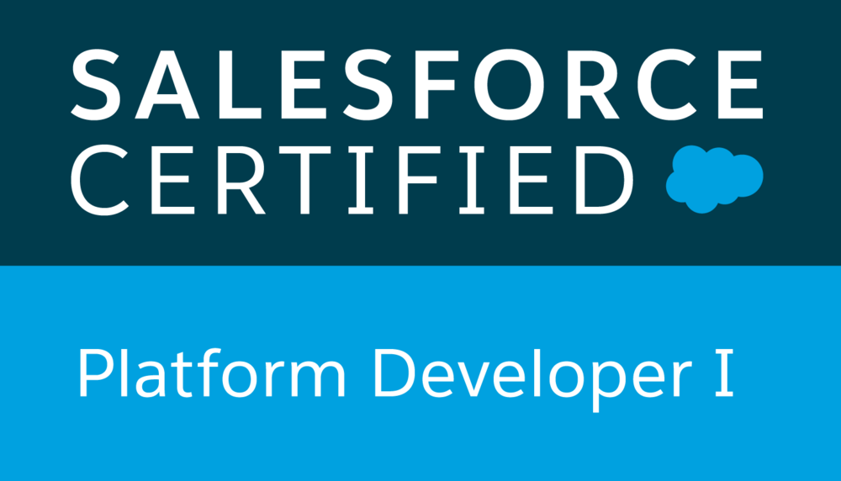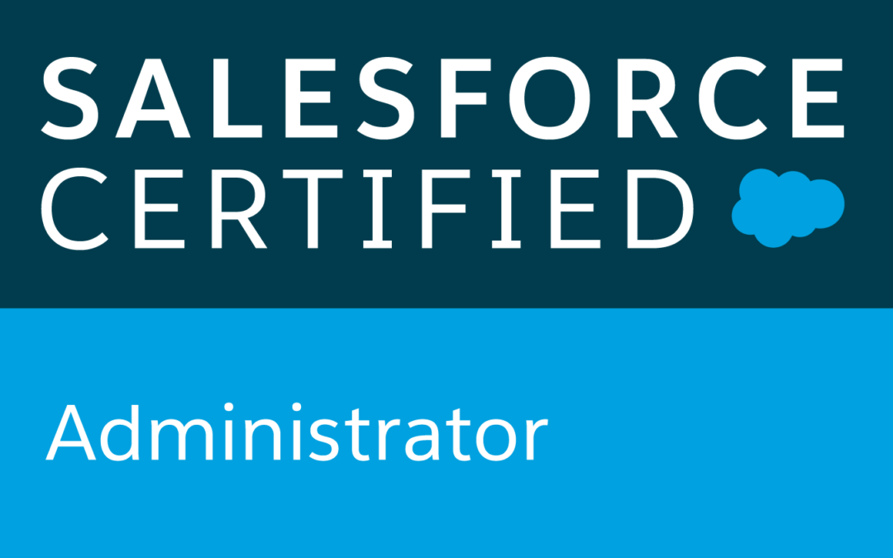
Name: Raghava Siddartha T (Certified Salesforce Developer)
Phone Number: (646)-844-0196 Email: siddarth0249@gmail.com
LinkedIn: https://www.linkedin.com/in/raghava-siddartha-t-53b8ba174/

SUMMARY:
- Having 8+ years of professional Software Development Experience with strong Object-Oriented Analysis, Designing and Programming skills with extensive experience including 5+ years in Salesforce.com CRM and Force.com platform with proficiency as a Developer and Administrator.
- Experience in Administration, Configuration, Implementation, Lightning, and support experience with Salesforce platform.
- Customized existing Visualforce to align with Salesforce new Lightning UI experience.
- Created multiple Lightning Components, added CSS and Design Parameters that makes the Lightning component look and feel better.
- Used Salesforce Lightning Design System (SLDS) for developing Lightning Components, Actions, Event and Server-Side Controller.
- Creating Lightning Components and used Salesforce SLDS to convert existing Visualforce pages to lightning components.
- Created Apex methods for the lightning controller and helper methods to perform DML operations on the case records.
- Used refined global search in Lightning by developing Apex classes and Controllers.
- Implemented and maintained Salesforce Service Cloud and Sales Cloud. Built custom Solutions with Apex and VisualForce.
- Worked extensively to gather requirements from sales team based on the customer information gathered from the opportunity related by sales representative of particular territory regions.
- Hands on experience in developing and customizing Salesforce.com applications using Apex classes, Apex Triggers, Visualforce, Page Layouts, Sharing Rules, S-Controls and migration tools.
- Skilled in querying Salesforce.com database using SOQL and SOSL queries with Governor Limitations.
- Strong experience in SFDC development using Apex classes, Triggers, Components, Reports, Force.com IDE, Eclipse with SOQL and Force.com plug-in.
- Proficient in salesforce administrative and development related tasks creating Users, Roles, Profiles, Visualforce pages, Validation Rules, Custom Reports, Workflows, Email Alerts, Reports and Dashboards, Page Layouts and Business Processes.
- Good experience in Salesforce.com Development by developing the presentation layer in Visualforce and business login in the Apex Programming by creating/ using the Classes, Triggers, Standard Controllers, Custom Controllers, Controller Extensions, S-Controls and Web Services API.
- Experience in implementing Security/Sharing rules, Configured permission sets, Field level Security, Record level Security and resource monitoring.
- Good understanding of Software Development Life Cycle (SDLC) and Agile with expertise in Requirement gathering, Analysis, Designing, Development and Testing.
- Used SOQL & SOSL with consideration to Governor Limits to get the customer information from different accounts.
- Experience in deployments of Apex and Visualforce pages across DEV, Test/QA and Production instances.
- Experience in integration of Salesforce.com applications with other applications with an emphasis of the Web Services/XML and other integration tools.
- In-depth knowledge of CRM processes like Sales, Marketing, Customer Service and Customer Support, Business processes, Customer Portal, Partner Portal which were used improve the business processes using Salesforce.com.
- Effective employment of Apex Data Loader, Import Wizard and Data Manipulation Language for data migration and management in bulk.
- Development of Salesforce using Eclipse IDE with Force.com Plug-in, Data Loader, Force.com Explorer, Metadata, SOAP and Web Services API.
- Good programming skills in frameworks like Java, JavaScript, SQL, CSS and HTML.
- Worked in all phases of Software Development Life cycle (SLDC) such as Agile, Scrum and Waterfall.
- Excellent technical skills along with the ability to communicate effectively and confidently with users, and team- members.
- Strong ability to prioritize tasks effectively and good at meeting deadlines.

TECHNICAL SKILLS:
Salesforce API Technologies | Eclipse, Apex Explorer, Offline Edition, App Exchange Data Loader
SFDC | Apex classes, Apex Triggers, Test Classes, Apex Custom Controllers and Extension, Visualforce (Pages, Components &Controllers), Validation Rules, Dashboards, Reports, Workflows, Custom Objects, Apex Web Services, Force.com IDE Plug-in, Sandbox development and testing, Apex Data Loader, Connect Offline, S-controls, SOQL, SOSL, Ajax Toolkit.
Salesforce Tools | App Exchange Data Loader, Data Loader, REST, SOAP API
Web Development | XML, HTML, CSS, JSP, JavaScript, JSON, Python
Languages | Java, C, C++, SQL
GUI and Tools | Eclipse, Visual Studio, Force.com IDE, Apex Data Loader
Platforms | Windows/XP/Vista/7, UNIX

CERTIFICATIONS:
- Salesforce.com Certified Platform Developer1
- Salesforce.com Certified Force.com Administrator (ADM 201)

WORK EXPERIENCE:

Robert Half, San Ramon, CA Jan 2019 – May 2020
Role: Salesforce Lightning Developer
Description:
Robert Half is a global human resource consulting firm based in Menlo Park, California founded in 1948. It is a member of the S&P 500 and is credited as being the world's first and largest accounting and finance staffing firm, with over 345 locations worldwide.
Responsibilities:

- Worked on Salesforce Community Cloud to provide access to employees, Customers and partners to salesforce data.
- Designed, developed and deployed Apex Classes, Controller Classes and Apex Triggers, packages for various functional needs in the application.
- Created Server-Side APEX Controller for Salesforce Lighting Experience and added Lighting Component to Lighting Pages and Record Pages.
- Designed, and developed the Custom objects, Validation rules, Page layouts, Custom tabs, Components, Visualforce Pages that suit to the needs of the application.
- Maintenance of installed Managed Packages in Lightning using Apex. Experienced in using Data Migration tool called Data Loader.
- Created modern Enterprise Lightning Apps combining Lightning Design System, Lightning App Builder and Lightning Component features.
- Worked on OWD, Role hierarchy, sharing rules, Apex callouts, Junction objects, roll-up summary fields, lookup relationships, and other field dependencies
- Written SOQL, SOSL Queries which are required in the apex classes, Triggers, Batch and Scheduled classes.
- Developed custom pages using Apex, Visualforce and controllers for customized UI of application work flow.
- Worked on automating complex business processes using workflows, approval process, dynamic approval process, validation rules and sharing rules.
- Used Apex Data loader to insert, Update and Import Data from Microsoft Excel into Salesforce.com.
- Worked on various salesforce.com standard objects like Campaigns, Leads, Accounts, Contacts, Opportunity, Forecast, Cases, Reports and Dashboards.
- Worked on Force.com Explorer for querying Salesforce database using SOQL & SOSL queries ad experience on Salesforce1 platform to build Mobile app by enabling Lightning components
- Worked with various business groups for design and solutioning of user requirements and participated in business/tech grooming sessions.
- Developed Lightning Web Components to access in Lightning Community.
- Integrated with external system by generating stubs from WSDL and made callouts to external application.
- Performed data migration, clean-up and integration activities using Data Loader and Informatica ETL tools.
- Provided the training to the internal business users to use the application and develop their own custom reports.
- Experienced in working with queues and generating them dynamically and assigning members to the queue based on the requirement.
- Migrated the code from personal sandbox to DEV by using GITHUB, JENKINS and migrated code from DEV to QA using Force.com IDE and ANT.

Environment: Salesforce.com platform, Community cloud, Quotes, Role Hierarchies, Sharing Rules, Email Templates, Reports, Dashboards, Custom Objects, Custom Tabs, Email Service, Security Controls, Data Loader, ANT, Microsoft Teams App, Change sets, Sandbox data loading, VS Code.
YETI , Austin, TX Jan 2018 – Dec 2018
Role: Salesforce Lightning Developer
Description:
Yeti was founded in 2006 with a simple mission: build the cooler we’d use every day if it existed. One that was built for the serious outdoor enthusiast rather than for the mass-discount retailers. Yeti decided early on that product innovation would come from necessity and firsthand experience — not from market research and data analysis. And Company never sacrifice quality for a few extra bucks. Because having your cooler’s lid cave in when using it as a casting platform should never be part of anyone’s fishing trip.
Responsibilities:
- Involved in various stages of Software Development Life cycle (SDLC) including analysis, requirements engineering, architecture design, development, enhancements, testing.
- Designed, developed and deployed Apex Classes, Controller Classes and Apex Triggers, packages for various functional needs in the application.
- Designed, developed and deployed Apex Classes Extension Classes to support Visualforce pages development, Test Classes for Unit testing and Apex Triggers for various functional needs in the application.
- Worked extensively in customization of Service Cloud Console by embedding Visualforce pages in custom console components, highlight panel and interaction log.
- Managed the implementation of single sign on for Salesforce and simplifying the login process and significantly improving user management.
- Experience in Salesforce.com data structures like Data Entry and usability, Reporting, Data Migration and App Integration.
- Involved in Setting up or create Admin options, User Interface, organization-wide defaults, role hierarchy, workflows and workflow rules.
- Experienced in working on a Lightning Component to create a My Licenses page where the customer can directly select their particular account and generate licenses without involving Customer Support.
- Knowledge on new release of lightning components and Lightning App Builder.
- Created Server-Side APEX Controller for Salesforce Lighting Experience and added Lighting Component to Lighting Pages and Record Pages.
- Worked extensively with lighting process builder flow, connect API, chatter and Quick Action.
- Creating of Lighting Application using lighting component and Salesforce Lighting Design System.
- Experience in Importing leads and contacts, modifying price lists, particularly if there are a lot of promotions and limited-time offers and changing delegation and escalation paths to account for absences or extended travel.
- Worked on OWD, Role hierarchy, sharing rules, Apex callouts, Junction objects, roll-up summary fields, lookup relationships, and other field dependencies.
- Implemented Marketing Sales, Customer Service, Call Center & Support Administration with Service Cloud.
- Involved in coding for modules for all the Sub-Application of the CRM application which involves extending existing SFDC standard components using Apex, Visual Force and other utilities.
- Used Apex Data loader to insert, Update and Import Data from Microsoft Excel into Salesforce.com.
- Worked on various salesforce.com standard objects like Campaigns, Leads, Accounts, Contacts, Opportunity, Forecast, Cases, Reports and Dashboards.
- Designed, and developed the Custom objects, Validation rules, Page layouts, Custom tabs, Components, Visualforce Pages that suit to the needs of the application.
- Worked with AppExchange to use managed packaged apps for improving application features.
- Increase functionality by installing AppExchange apps to enable Customer Service Surveys.
- Developed Visualforce Pages, Visualforce Custom Controllers Components, Advanced Search Functionality, Custom Objects, Analytic Snapshots, Tabs, Tags and Components.
- Assist with project implementation and control monitoring process related to quality assurance (QA) and user assisted testing (UAT).
- Worked in different sandboxes for development and testing and involved in migrating the code into production instance in installment using change sets.
- Integrated SFDC with Oracle Apps via fusion Middleware using SOAP based Integration on both Standard and Custom Objects.
- Performed detailed analysis of business and technical requirements and developed the Apex classes using other Platform based technologies like Visualforce, Force.com IDE.
- On the basis of the organizational needs, developed and configured various Reports for different user profiles.
- Maintained data cleanliness and accuracy by adding custom validation rules, custom formulas, reports and dashboards.
Environment: Salesforce.com platform, Service cloud, Quotes, Role Hierarchies, Sharing Rules, Email Templates, Oracle, Reports, Dashboards, Custom Objects, Custom Tabs, Email Service, Security Controls, Data Loader, ANT, Slack App, Change sets.
Symantec, Mountain View, CA April 2017 – Dec 2017
Role: Sr. Salesforce Developer
Description: Symantec Corporation is an American software company headquartered in Mountain View, California, United States. The company provides cybersecurity software and services. Symantec is a Fortune 500 company and a member of the S&P 500 stock-market index.

Responsibilities:
- Implemented SFDC CRM to deliver various reports in departments of Sales, Administration and Marketing etc.
- Created Objects and fields, Relationships and Record Types, Page Layouts, Profiles and Assignments Rules.
- Involved in Design and development of Workflow Rules, Triggers, Validation Rules, and other customizations with Salesforce.com.
- Developed many requirements using metadata and change set.
- Worked on developing customer portal for developed an application for portal users.
- Created Limited Lightning Apps combing Lightning Design System, Lighting App Builder and Lightning Component features.
- Experienced working on writing SOQL and SOSL queries.
- Developed complex formula to calculate response times an show flags reminding customer service reps.
- Involving in doing unit testing by writing test class and working with UAT.
- Worked on Force.com Explorer for querying Salesforce database using SOQL & SOSL queries ad experience on Salesforce1 platform to build Mobile app by enabling Lightning components.
- Customized Salesforce.com User profiles by setting Standard and Custom objects, Custom App, Field level Security, Permission Sets for Client services and Marketing.
- Provided Case Management by configuring Email-to-Case for end user to submit a case through Outlook.
- Experienced in creating service cloud workflows like Key customer case notification and notifying relevant people in a high priority case.
- Personalized the user interface for each user or user group so customers are presented with the precise information they need using Customer portal.
- Increased the visibility of costs incurred during manufacturing processes by developing a cost accounting module that integrated into the existing ERP.
- Implemented Marketing Sales, Customer Service, Call Center & Support Administration.
- Developed data migration scripts and also implementing data cleansing tools.
- Customized the Dashboards to the track usage for productivity and performance of business centers and their sales teams.
- Designed, Implemented and deployed the Custom objects, Page layouts, Custom tabs, Components, and S Control to suit to the needs of the application.
- Created Custom Objects and defined lookup and master-detail relationships on the objects and created junction objects to establish many-to-many relationship among objects.
- Used Metadata API within Salesforce to access workflow rules and picklist fields.
- Developed custom pages using Apex, Visualforce and controllers for customized UI of application workflow.
- Worked as a Salesforce Chatter APP with the organization and regularly participated in the meetings and chatter community.
- Developed various Visualforce pages to manage sales plan call sheets within Salesforce, capturing prep data and call activity.
- Implemented various Custom Reports and deployed them for different business user levels.
- Conducted meetings with on-shore and off-shore teams to update with the project status.
- Migrated the code from personal sandbox to DEV by using GITHUB, JENKINS and migrated code from DEV to QA using Force.com IDE and ANT.
- Implemented escalation rules, automatic case generation and their escalation to call center representative, and generated email alerts for quick issue resolution.
Environment: Saleforce.com platform, Apex Language, Visualforce (Pages, Component & Controllers), Pages, Data Loader, S-Controls, HTML, Java Script, Apex Triggers, Web Services, Reports, Custom Objects, Custom Tabs, Email Services, Security Controls, Service Cloud, Sandbox data loading, Eclipse IDE Plug-in.
Navion Health Care Solutions, Indianapolis Oct 2015 – March 2017
Role: Salesforce Administrator/Mid-Level Developer
Description:
Navion is committed to assisting its hospital and physician partners to improve patient care while improving efficiency. With strong roots in a faith-based organization, Navion keeps its mission and vision at the forefront of business operations in all that it does.
Responsibilities:
- Administered, configured, maintained Salesforce.com application user profiles, roles, assigning Permissions, Validation Rule, upgrade installation.
- Provided development, implementation and updating focusing on sales cloud and service cloud.
- Worked on Salesforce.com standard objects such as Accounts, Contacts, Opportunities, Campaigns, Cases, and Solutions.
- Designed, and developed the Custom objects, Page layouts, Custom tabs, Components, Visual force Pages as a Salesforce consultant.
- Created and deployed Several Reports using salesforce.com platform.
- Worked with force.com developer toolkit including visual force pages, apex classes, apex controllers and apex triggers to develop custom business logic.
- Assisted end users to use salesforce.com and also analyzed and evaluated complex business requirements and recommended solutions.
- Developed and deployed workflows and approval processes for opportunities and products/assets management.
- Implemented the requirements on Salesforce.com platform and Force.com IDE Plug-in using Eclipse.
- Imported data from excel sheets in to Leads, Accounts, Contacts and Opportunities using Data Loader and Import Wizard.
- Involved in Data mapping specifications to create and execute detailed system test plans. The data mapping specifies what data will be extracted from an internal data warehouse, transformed and sent to salesforce.com entity.
- Developed workflow rules, tasks, emails and alerts to track customer related tasks and activities.
- Used sandbox as part of testing and data migration.
Environment: Saleforce.com platform, Apex Language, VisualForce Pages, Data Loader, S-Controls, HTML, Java Script, Apex Triggers, Web Services, Reports, Custom Objects, Custom Tabs, Email Services, Security Controls, Sandbox data loading, Eclipse IDE Plug-in.

Zensar Technologies, Pune, India Aug 2013 – July 2015
Role: Salesforce Developer/ Administrator
Description:
Zensar Technologies Limited, a digital solutions and technology services company, provides information technology (IT) services and solutions. The company operates through Application Management Services and Infrastructure Management Services segments.
Responsibilities:
- Performed various activities as part of the project like gathering information, analyzing the information, and documenting the functional and non- functional requirements. Then after, implemented the requirements on Salesforce.com platform and Force.com IDE Plug-in using Eclipse.
- Worked with various salesforce.com objects like Accounts, Contacts, Leads, Campaigns, Reports, and Dashboards. Additionally, developed various Custom Objects, Tabs, Components and Visual Force Pages.
- Created various users along with the creation of specific roles, profile and appropriate Permission sets for them.
- Created and deployed several Reports using salesforce.com platform along with the development of custom objects.
- Developed Apex Classes, Controller Classes and Apex Triggers for various functional needs in the application along with the test classes for them.
- Responsible for addition of pick list values, modification of page layouts, and also creation of email templates using VisualForce.
- Created and maintained documentation on processes, application configuration, and training material for users and provided ongoing support.
- Used sandbox for testing and then migrated the code to the deployment instance.
Environment: Force.com IDE, Force.com Sandbox, Import Wizard, Apex, Controllers, Custom objects, Reports, Visual Force Pages, Apex Triggers.

Micro Spark IT Research and Development Pvt Ltd –Hyderabad, India May 2010 to July 2013
Role: Java Developer
Description:
Micro Spark Pvt Ltd is one of the leading professional service midlevel companies, transforming clients' business, operating and technology models for the digital era. Our unique industry-based, consultative approach helps clients envision, build and run more innovative and efficient businesses.
Responsibilities:
- Involved in various stages of the project life cycle primarily design, implementation, testing, deployment and enhancement of the application.
- Involved in the creation of Use Cases, Class Diagrams and Sequence Diagrams for analysis and design of application.
- Designed and developed web pages using JSP, HTML and used JavaScript for client-side validation. Responsible for testing of application on various levels like integration and System testing by utilizing various methodologies.
- Worked on the development of various web applications based on the client needs.
- Responsible for maintenance and production support of the application documented design and functional aspects of the application.
- Record technology solutions involving user needs documents, user manual design decisions and executive summaries across projects.
- Responsible for proactively monitoring performance, diagnosing problems and tuning queries and databases.
- Developed data model and stored procedures.
- Developed user interface screens, and administrative screens using JSP and JavaScript to perform checking and validation at Client’s side.
- Developed new java code and executed new features through business requirements.
- Extensively used SQL to generate stored procedures and functions to use with Java.
Environment: Java Servlets, JSP, JavaScript, XML, CSS, HTML, Apache Tomcat, JDBC, Oracle 10g, SQL
Education: Bachelor’s Degree in Computer Science Engineering from Jawaharlal Nehru Technological University (2010), India.

